

# Advanced Data Structures Sartaj Sahni

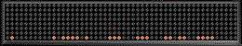

Clip Art Sources

* [www.barrysclipart.com](http://www.barrysclipart.com/)
* [www.livinggraphics.com](http://www.livinggraphics.com/)
* [www.rad.kumc.edu](http://www.rad.kumc.edu/)
* [www.livinggraphics.com](http://www.livinggraphics.com/)
* Study data structures for:
  + External sorting
  + Single and double ended priority queues
  + Dictionaries
  + Multidimensional search
  + Computational geometry
  + Image processing
  + Packet routing and classification
  + …

## Concerned with:

* + Worst-case complexity
  + Average complexity
  + Amortized complexity

# Prerequisites

* C, C++, Java, or Python
* Asymptotic Complexity
  + Big Oh, Theta, and Omega notations
* Undergraduate data structures
  + Stacks and Queues
  + Linked lists
  + Trees
  + Graphs

# Web Site

* [www.cise.ufl.edu/~sahni/cop5536](http://www.cise.ufl.edu/~sahni/cop5536)
* [http://elearning.ufl.edu](http://elearning.ufl.edu/)
* Handouts, syllabus, readings, assignments, past exams, past exam solutions, TAs, Internet lectures, PowerPoint presentations, etc.

# Assignments, Tests, & Grades

* 25% for assignments
  + There will be two assignments.
* 25% for each test
  + There will be three tests.

# Grades (Rough Cutoffs)

* A >= 85%
* A- >= 81%
* B+ >= 77%
* B >= 72%
* B- >= 67%
* C+ >= 63%
* C >= 60%
* C- >= 55%

# Kinds Of Complexity

* Worst-case complexity.
* Average complexity.
* Amortized complexity.
* Operations
  + Initialize
  + Insert
  + Delete
* Examples
  + Linear List
  + Stack
  + Queue
  + …
* Suppose that the worst-case complexity is
  + Initialize O(1)
  + Insert O(s)
  + Delete O(s)

where s is the size of Z.

* How much time does it take to perform a sequence of 1 initialize followed by n inserts and deletes?
* O(n2)
* Suppose further that the average complexity is
  + Initialize O(1)
  + Insert O(log s)
  + Delete O(log s)
* How much time does it take to perform a sequence of 1 initialize followed by n inserts and deletes?
* O(n2)
* Initialize Z
* Solve P by performing many inserts and deletes plus other tasks.
* Examples
  + Dijkstra’s single-source shortest paths
  + Minimum cost spanning trees
* Total time to solve P using Z is

time for inserts/deletes + time for other tasks

= O(n2) + time for other tasks

where n is the number of inserts/deletes

At times a better bound can be obtained using amortized complexity.

* The amortized complexity of a task is the amount you charge the task.
* The conventional way to bound the cost of doing a task n times is to use one of the expressions
  + n*(worst-case cost of task)
  + worst-case cost of task i
* The amortized complexity way to bound the cost of doing a task n times is to use one of the expressions
  + n*(amortized cost of task)
  + amortized cost of task i
* The amortized complexity of a task may bear no direct relationship to the actual complexity of the task. I.e., it may be <, =, or > actual task complexity.
* In worst-case complexity analysis, each task is charged an amount that is >= its cost. So,

actual cost of task i

 worst-case cost of task i)

* In amortized analysis, some tasks may be charged an amount that is < their cost. The amount charged must ensure:

actual cost of task i

 amortized cost of task i)

# Potential Function P()

* + P(i) = amortizedCost(i) – actualCost(i) + P(i – 1)
  + (P(i) – P(i–1)) =

(amortizedCost(i) –actualCost(i))

* + P(n) – P(0) = (amortizedCost(i) –actualCost(i))
  + P(n) – P(0) >= 0
  + When P(0) = 0, P(i) is the amount by which the first i tasks/operations have been over charged.
    - Rewrite an arithmetic statement as a sequence of statements that do not use parentheses.
    - a = x+((a+b)*c+d)+y;

is equivalent to the sequence: z1 = a+b;

z2 = z1*c+d; a = x+z2+y;

a = x+((a+b)*c+d)+y;

* + - * The rewriting is done using a stack and a method processNextSymbol.
      * create an empty stack; for (int i = 1; i <= n; i++)

// n is number of symbols in statement processNextSymbol();

a = x+((a+b)*c+d)+y;

* + - processNextSymbol extracts the next symbol from the input statement.
    - Symbols other than ) and ; are simply pushed on to the stack.

b

+

a (

(

+

x

=

a

a = x+((a+b)*c+d)+y;

* + - If the next symbol is ), symbols are popped from the stack up to and including the first (, an assignment statement is generated, and the left hand symbol is added to the stack.

b

+

a (

(

+

x

=

a

z1 = a+b;

a = x+((a+b)*c+d)+y;

* + - If the next symbol is ), symbols are popped from the stack up to and including the first (, an assignment statement is generated, and the left hand symbol is added to the stack.

d

+

c

z1 (

+

x

*

=

a

z1 = a+b;

z2 = z1*c+d;

a = x+((a+b)*c+d)+y;

* + - If the next symbol is ), symbols are popped from the stack up to and including the first (, an assignment statement is generated, and the left hand symbol is added to the stack.

y

+

z2

+

x

=

a

z1 = a+b;

z2 = z1*c+d;

a = x+((a+b)*c+d)+y;

* + - If the next symbol is ;, symbols are popped from the stack until the stack becomes empty. The final assignment statement

y

+

z2

+

x

=

a

a = x+z2+y; is generated.

z1 = a+b;

z2 = z1*c+d;

## Complexity Of processNextSymbol

a = x+((a+b)*c+d)+y;

* + - O(number of symbols that get popped from stack)
    - O(i), where i is for loop index.

## Overall Complexity (Conventional Analysis)

create an empty stack;

for (int i = 1; i <= n; i++)

// n is number of symbols in statement processNextSymbol();

* + - * So, overall complexity is O(i) = O(n2).
      * Alternatively, O(n*n) = O(n2).
      * Although correct, a more careful analysis permits us to conclude that the complexity is O(n).

# Ways To Determine Amortized Complexity

* + - Aggregate method.
    - Accounting method.
    - Potential function method.
    - Somehow obtain a good upper bound on the actual cost of the n invocations of processNextSymbol()
    - Divide this bound by n to get the amortized cost of one invocation of processNextSymbol()
    - Easy to see that

actual cost  amortized cost

* The actual cost of the n invocations of processNextSymbol()

equals number of stack pop and push operations.

* The n invocations cause at most n symbols to be pushed on to the stack.
* This count includes the symbols for new variables, because each new variable is the result of a ) being processed. Note that no )s get pushed on to the stack.
* The actual cost of the n invocations of processNextSymbol()

is at most 2n.

* So, using 2n/n = 2 as the amortized cost of processNextSymbol()

is OK, because this cost results in

actual cost  amortized cost

* Since the amortized cost of processNextSymbol()

is 2, the actual cost of all n invocations is at most 2n.

* The aggregate method isn’t very useful, because to figure out the amortized cost we must first obtain a good bound on the aggregate cost of a sequence of invocations.
* Since our objective was to use amortized complexity to get a better bound on the cost of a sequence of invocations, if we can obtain this better bound through other techniques, we can omit dividing the bound by n to obtain the amortized cost.

# Amortized Complexity

* + Aggregate method.
* Accounting method.
* Potential function method.

# Potential Function P()

* P(i) = amortizedCost(i) – actualCost(i) + P(i – 1)
* (P(i) – P(i – 1)) =

(amortizedCost(i) –actualCost(i))

* P(n) – P(0) = (amortizedCost(i) –actualCost(i))
* P(n) – P(0) >= 0
* When P(0) = 0, P(i) is the amount by which the first i operations have been over charged.

# Potential Function Example

|  |  |  |  |
| --- | --- | --- | --- |
| a = x + ( ( a + b | | ) * c + d | ) + y ; |
| actual cost | 1 1 1 1 1 11 1 1 | 5 1 1 1 1 7 1 1 7 | |
| amortized cost | 2 2 2 2 2 22 2 2 | 2 2 2 2 2 2 2 2 2 | |
| potential | 1 2 3 4 5 67 8 9 | 6 7 8 910 5 6 7 2 | |

Potential = stack size except at end.

# Accounting Method

* + Guess the amortized cost.
  + Show that P(n) – P(0) >= 0.

## Accounting Method Example

create an empty stack;

for (int i = 1; i <= n; i++)

// n is number of symbols in statement processNextSymbol();

* + - Guess that amortized complexity of processNextSymbol is 2.
    - Start with P(0) = 0.
    - Can show that P(i) >= number of elements on stack after ith symbol is processed.

# Accounting Method Example

|  |  |  |  |
| --- | --- | --- | --- |
| a = x + ( ( a + b | | ) * c + d | ) + y ; |
| actual cost | 1 1 1 1 1 11 1 1 | 5 1 1 1 1 7 1 1 7 | |
| amortized cost | 2 2 2 2 2 22 2 2 | 2 2 2 2 2 2 2 2 2 | |
| potential | 1 2 3 4 5 67 8 9 | 6 7 8 910 5 6 7 2 | |

* + Potential >= number of symbols on stack.
  + Therefore, P(i) >= 0 for all i.
  + In particular, P(n) >= 0.

# Potential Method

* + Guess a suitable potential function for which P(n) – P(0) >= 0 for all n.
  + Derive amortized cost of ith operation using

P = P(i) – P(i–1)

= amortized cost – actual cost

* + amortized cost = actual cost + P

## Potential Method Example

create an empty stack;

for (int i = 1; i <= n; i++)

// n is number of symbols in statement processNextSymbol();

* + - Guess that the potential function is P(i) = number of elements on stack after ith symbol is processed (exception is P(n) = 2).
    - P(0) = 0 and P(i) – P(0) >= 0 for all i.

# ith Symbol Is Not ) or ;

* + Actual cost of processNextSymbol is 1.
  + Number of elements on stack increases by 1.
* P = P(i) – P(i–1) = 1.
  + amortized cost = actual cost + P

= 1 + 1 = 2

# ith Symbol Is )

* + Actual cost of processNextSymbol is #pops + 1.
  + Number of elements on stack decreases by #pops –1.
* P = P(i) – P(i–1) = 1 – #pops.
  + amortized cost = actual cost + P

= #pops + 1 + (1 – #pops)

= 2

# ith Symbol Is ;

* + Actual cost of processNextSymbol is #pops = P(n–1).
  + Number of elements on stack decreases by P(n–1).
* P = P(n) – P(n–1) = 2 – P(n–1).
  + amortized cost = actual cost + P

= P(n–1) + (2 – P(n–1))

= 2

# Binary Counter

* + n-bit counter
  + Cost of incrementing counter is number of bits that change.
  + Cost of 001011 => 001100 is 3.
  + Counter starts at 0.
  + What is the cost of incrementing the counter m times (m <= 2n-1)?

# Worst-Case Method

* + Worst-case cost of an increment is n.
  + Cost of 011111 => 100000 is 6.
  + So, the cost of m increments is at most mn.

0 0 0 0 0

counter

* + - Each increment changes bit 0 (i.e., the right most bit).
    - Exactly floor(m/2) increments change bit 1 (i.e., second bit from right).
    - Exactly floor(m/4) increments change bit 2.

0 0 0 0 0

counter

* Exactly floor(m/8) increments change bit 3.
* So, the cost of m increments is

m + floor(m/2) + floor(m/4) + .... < 2m

* Amortized cost of an increment is 2m/m = 2.

# Accounting Method

* Guess that the amortized cost of an increment is 2.
* Now show that P(m) – P(0) >= 0 for all m.
* 1st increment:
  + one unit of amortized cost is used to pay for the change in bit 0 from 0 to 1.
  + the other unit remains as a credit on bit 0 and is used later to pay for the time when bit 0 changes from 1 to 0.

|  |  |  |
| --- | --- | --- |
| bits | 0 0 0 0 0 | 0 0 0 0 1 |
| credits | 0 0 0 0 0 | 0 0 0 0 1 |

2nd Increment.

|  |  |  |
| --- | --- | --- |
| bits | 0 0 0 0 1 | 0 0 0 1 0 |
| credits | 0 0 0 0 1 | 0 0 0 1 0 |

* + - one unit of amortized cost is used to pay for the change in bit 1 from 0 to 1
    - the other unit remains as a credit on bit 1 and is used later to pay for the time when bit 1 changes from 1 to 0
    - the change in bit 0 from 1 to 0 is paid for by the credit on bit 0

3rd Increment.

|  |  |  |
| --- | --- | --- |
| bits | 0 0 0 1 0 | 0 0 0 1 1 |
| credits | 0 0 0 1 0 | 0 0 0 1 1 |

* + - one unit of amortized cost is used to pay for the change in bit 0 from 0 to 1
    - the other unit remains as a credit on bit 0 and is used later to pay for the time when bit 1 changes from 1 to 0

4th Increment.

|  |  |  |
| --- | --- | --- |
| bits | 0 0 0 1 1 | 0 0 1 0 0 |
| credits | 0 0 0 1 1 | 0 0 1 0 0 |

* + - one unit of amortized cost is used to pay for the change in bit 2 from 0 to 1
    - the other unit remains as a credit on bit 2 and is used later to pay for the time when bit 2 changes from 1 to 0
    - the change in bits 0 and 1 from 1 to 0 is paid for by the credits on these bits

# Accounting Method

* P(m) – P(0) = (amortizedCost(i) –actualCost(i))

= amount by which the first m increments have been over charged

= number of credits

= number of 1s in binary rep. of m

>= 0

* + Guess a suitable potential function for which P(n) – P(0) >= 0 for all n.
  + Derive amortized cost of ith operation using

P = P(i) – P(i–1)

= amortized cost – actual cost

* + amortized cost = actual cost + P
* Guess P(i) = number of 1s in counter after ith increment.
* P(i) >= 0 and P(0) = 0.
* Let q = # of 1s at right end of counter just before ith increment (01001111 => q = 4).
* Actual cost of ith increment is 1+q.
* P = P(i) – P(i – 1) = 1 – q (0100111 => 0101000)
* amortized cost = actual cost + P

= 1+q + (1 – q) = 2

# External Sorting

* + Sort n records/elements that reside on a disk.
  + Space needed by the n records is very large.
    - n is very large, and each record may be large or small.
    - n is small, but each record is very large.
  + So, not feasible to input the n records, sort, and output in sorted order.

# Small n But Large File

* Input the record keys.
* Sort the n keys to determine the sorted order for the n records.
* Permute the records into the desired order (possibly several fields at a time).
* We focus on the case: large n, large file.

# New Data Structures/Concepts

* Tournament trees.
* Huffman trees.
* Double-ended priority queues.
* Buffering.
* Ideas also may be used to speed algorithms for small instances by using cache more efficiently.

# External Sort Computer Model

MAIN

DISK

ALU

Disk Characteristics (HDD)

read/write head

tracks

* Seek time
  + Approx. 100,000 arithmetics
* Latency time
  + Approx. 25,000 arithmetics
* Transfer time
* Data access by block

# Traditional Internal Memory Model

MAIN

ALU

Matrix Multiplication

for (int i = 0; i < n; i++) for (int j = 0; j < n; j++)

for (int k = 0; k < n; k++) c[i][j] += a[i][k] * b[k][j];

* ijk, ikj, jik, jki, kij, kji orders of loops yield same result.
* All perform same number of operations.
* But run time may differ significantly!

# More Accurate Memory Model

ALU

8-32 32KB 256KB 1GB

1C 2C 10C 100C

R

MAIN

L2

L1

## 2D Array Representation In Java, C, and C++

x[]

|  |  |  |  |
| --- | --- | --- | --- |
| a | b | c | d |

int x[3][4];

|  |  |  |  |
| --- | --- | --- | --- |
| e | f | g | h |

|  |  |  |  |
| --- | --- | --- | --- |
| i | j | k | l |



# ijk Order

. . . . . .

. . . . . .

. . . . . .

. . . . . .

. . . . . .

. . . . . .

. . . . . .

. . . . . .

. . . . . .

. . . . . .

. . . . . .

. . . . . .

for (int i = 0; i < n; i++) for (int j = 0; j < n; j++)

for (int k = 0; k < n; k++) c[i][j] += a[i][k] * b[k][j];



. . . . . .

. . . . . .

. . . . . .



. . . . . .

. . . . . .

. . . . . .



# ijk Analysis



. . . . . .

. . . . . .

. . . . . .

. . . . . .

. . . . . .

. . . . . .



. . . . . .

. . . . . .

. . . . . .

. . . . . .

. . . . . .

. . . . . .



. . . . .

. . . . .

.

.

.

.

.

.

. . . . .



. . . . .

. . . . .

. . . . .

* Block size = width of cache line = w.
* Assume one-level cache.
* C => n2/w cache misses.
* A => n3/w cache misses, when n is large.
* B => n3 cache misses, when n is large.
* Total cache misses = n3/w(1/n + 1 + w).

# ikj Order

. . . . . .

. . . . . .

. . . . . .

. . . . . .

. . . . . .

. . . . . .

. . . . . .

. . . . . .

. . . . . .

. . . . . .

. . . . . .

. . . . . .

. . . . . .

. . . . . .

. . . . . .

. . . . . .

. . . . . .

. . . . . .

for (int i = 0; i < n; i++)

for (int k = 0; k < n; k++) for (int j = 0; j < n; j++)

c[i][j] += a[i][k] * b[k][j];



# ikj Analysis



. . . . . .

. . . . . .

. . . . . .

. . . . . .

. . . . . .

. . . . . .



. . . . . .

. . . . . .

. . . . . .

. . . . . .

. . . . . .

. . . . . .

. . . . . .

. . . . . .

. . . . . .

. . . . . .

. . . . . .

. . . . . .





* C => n3/w cache misses, when n is large.
* A => n2/w cache misses.
* B => n3/w cache misses, when n is large.
* Total cache misses = n3/w(2 + 1/n).

# ijk Vs. ikj Comparison

* ijk cache misses = n3/w(1/n + 1 + w).
* ikj cache misses = n3/w(2 + 1/n).
* ijk/ikj ~ (1 + w)/2, when n is large.
* w = 4 (32-byte cache line, double precision data)
  + ratio ~ 2.5.
* w = 8 (64-byte cache line, double precision data)
  + ratio ~ 4.5.
* w = 16 (64-byte cache line, integer data)
  + ratio ~ 8.5.

# Prefetch

* + Prefetch can hide memory latency
  + Successful prefetch requires ability to predict a memory access much in advance
  + Prefetch cannot reduce energy as prefetch does not reduce number of memory accesses

# Faster Internal Sorting

* + May apply external sorting ideas to internal sorting.
  + Internal tiled merge sort gives 2x (or more) speedup over traditional merge sort.

# External Sort Methods

* + Base the external sort method on a fast internal sort method.
  + Average run time
    - Quick sort
  + Worst-case run time
    - Merge sort

# Internal Quick Sort

|  |  |  |  |  |  |  |  |  |  |  |
| --- | --- | --- | --- | --- | --- | --- | --- | --- | --- | --- |
| 6 | 2 | 8 | 5 | 11 | 10 | 4 | 1 | 9 | 7 | 3 |

Use 6 as the pivot.

|  |  |  |  |  |  |  |  |  |  |  |
| --- | --- | --- | --- | --- | --- | --- | --- | --- | --- | --- |
| 2 | 5 | 4 | 1 | 3 | 6 | 7 | 9 | 10 | 11 | 8 |

Sort left and right groups recursively.

|  |  |  |
| --- | --- | --- |
| Middle group | | |
| input | small | large |

* 3 input/output buffers

DISK

* + input, small, large
* rest is used for middle group

|  |  |  |
| --- | --- | --- |
| Middle group | | |
| input | small | large |

* fill middle group and input buffer from disk

DISK

* if next record <= middlemin send to small
* else if next record >= middlemax send to large
* else remove middlemin or middlemax from middle and add new record to middle group

|  |  |  |
| --- | --- | --- |
| Middle group | | |
| input | small | large |

* Fill input buffer when it gets empty.

DISK

* Write small/large buffer when full.
* Write middle group in sorted order when done.
* Double-ended priority queue.
* Use additional buffers to reduce I/O wait time.

# External Sorting

* Adapt fastest internal-sort methods.
* Quick sort …best average run time.
* Merge sort … best worst-case run time.

# Internal Merge Sort Review

* Phase 1
  + Create initial sorted segments
    - Natural segments
    - Insertion sort
* Phase 2
  + Merge pairs of sorted segments, in merge passes, until only 1 segment remains.
* Sort 10,000 records.
* Enough memory for 500 records.
* Block size is 100 records.
* tIO = time to input/output 1 block

(includes seek, latency, and transmission times)

* tIS = time to internally sort 1 memory load
* tIM = time to internally merge 1 block load

## Two phases.

* + Run generation.
    - A run is a sorted sequence of records.
  + Run merging.

# Run Generation

10,000 records

DISK

MEMORY

500 records

5 blocks

100 blocks

* Input 5 blocks.
* Sort.
* Output as a run.
* Do 20 times.
* 5tIO
* tIS
* 5tIO
* 200tIO + 20tIS

# Run Merging

* Merge Pass.
  + Pairwise merge the 20 runs into 10.
  + In a merge pass all runs (except possibly one) are pairwise merged.
* Perform 4 more merge passes, reducing the number of runs to 1.

# Merge 20 Runs

R1 R2 R3 R4 R5 R6 R7 R8 R9 R10 R11 R12 R13 R14 R15 R16 R17 R18 R19 R20

S9

S1 S2 S3 S4 S5 S6 S7 S8

T4

S10

T1 T2 T3 T5

U1 U2 U3

V1 V2

W1

# Merge R1 and R2

|  |  |
| --- | --- |
|  | |
| Output | |
| Input 0 | Input 1 |

* Fill I0 (Input 0) from R1 and I1 from R2.

DISK

* Merge from I0 and I1 to output buffer.
* Write whenever output buffer full.
* Read whenever input buffer empty.

# Time To Merge R1 and R2

* + Each is 5 blocks long.
  + Input time = 10tIO.
  + Write/output time = 10tIO.
  + Merge time = 10tIM.
  + Total time = 20tIO + 10tIM .

# Time For Pass 1 (RS)

* + Time to merge one pair of runs

= 20tIO + 10tIM .

* + Time to merge all 10 pairs of runs

= 200tIO + 100tIM .

# Time To Merge S1 and S2

* + Each is 10 blocks long.
  + Input time = 20tIO.
  + Write/output time = 20tIO.
  + Merge time = 20tIM.
  + Total time = 40tIO + 20tIM .

# Time For Pass 2 (S T)

* + Time to merge one pair of runs

= 40tIO + 20tIM .

* + Time to merge all 5 pairs of runs

= 200tIO + 100tIM .

# Time For One Merge Pass

* + Time to input all blocks = 100tIO.
  + Time to output all blocks = 100tIO.
  + Time to merge all blocks = 100tIM .
  + Total time for a merge pass = 200tIO + 100tIM .

# Total Run-Merging Time

* (time for one merge pass) * (number of passes)

= (time for one merge pass)

* ceil(log2(number of initial runs))

= (200tIO + 100tIM) * ceil(log2(20))

= (200tIO + 100tIM) * 5

# Factors In Overall Run Time

* + Run generation. 200tIO + 20tIS
    - Internal sort time.
    - Input and output time.
  + Run merging. (200tIO + 100tIM) * ceil(log2(20))
    - Internal merge time.
    - Input and output time.
    - Number of initial runs.
    - Merge order (number of merge passes is determined by number of runs and merge order)
    - Overlap input, output, and internal sorting.

DISK

DISK

MEMORY

* + Generate runs whose length (on average) exceeds memory size.
  + Equivalent to reducing number of runs generated.
    - Overlap input, output, and internal merging.

DISK

DISK

MEMORY

* + Reduce number of merge passes.
* Use higher-order merge.
* Number of passes

= ceil(logk(number of initial runs)) where k is the merge order.

# Merge 20 Runs Using 5-Way Merging

R1 R2 R3 R4 R5 R6 R7 R8 R9 R10 R11 R12 R13 R14 R15 R16 R17 R18 R19 R20

S1 S2 S3 S4

T1

Number of passes = 2

* + Number of input buffers needed is linear in merge order k.
  + Since memory size is fixed, block size decreases as k increases (after a certain k).
  + So, number of blocks increases.
  + So, number of seek and latency delays per pass increases.

I/O time per pass

merge order k

# Total I/O Time To Merge Runs

* (I/O time for one merge pass)

* ceil(logk(number of initial runs))

Total I/O time to merge runs

merge order k

# Internal Merge Time

O

R1 R2 R3 R4 R5 R6

* Naïve way => k – 1 compares to determine next record to move to the output buffer.
* Time to merge n records is c(k – 1)n, where c is a constant.
* Merge time per pass is c(k – 1)n.
* Total merge time is c(k – 1)nlogkr  cn(k/log2k) log2r.

Merge Time Using A Tournament Tree

O

R1 R2 R3 R4 R5 R6

* Time to merge n records is dnlog2k, where d is a constant.
* Merge time per pass is dnlog2k.
* Total merge time is (dnlog2k) logkr = dnlog2r.

# Tournament Trees

Winner trees. Loser Trees.

# Winner Tree – Definition

Complete binary tree with n-1 internal nodes and n external nodes.

External nodes represent tournament players.

Each internal node represents a match played between its two children; the winner of the match is stored at the internal node.

Root has overall winner.

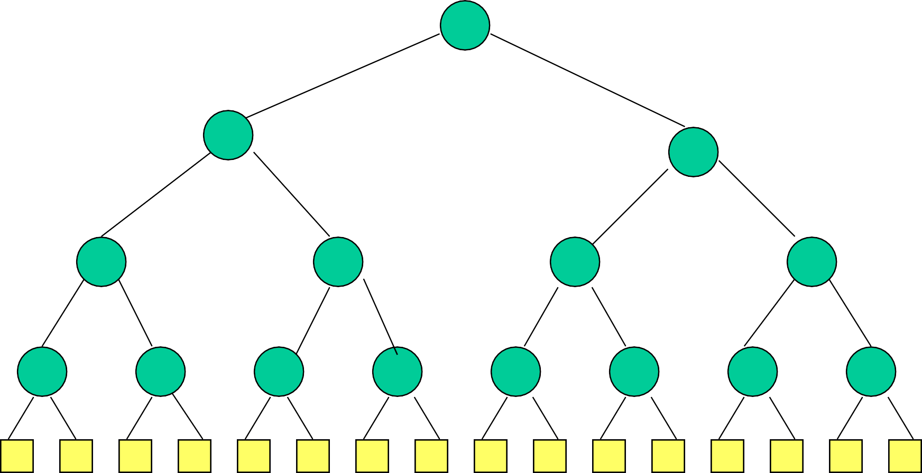

player 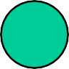 match node

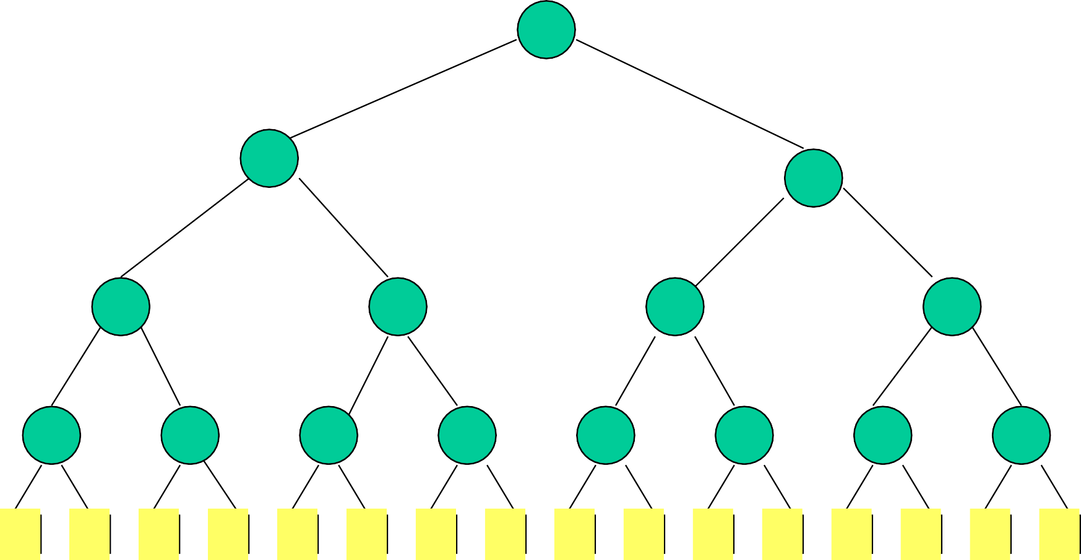1

1 2

3 1 2 2

3 6 1 3 2 4 2 5

4 3 6 8 1 5 7 3 2 6 9 4 5 2 5 8

Smaller element wins => min winner tree.

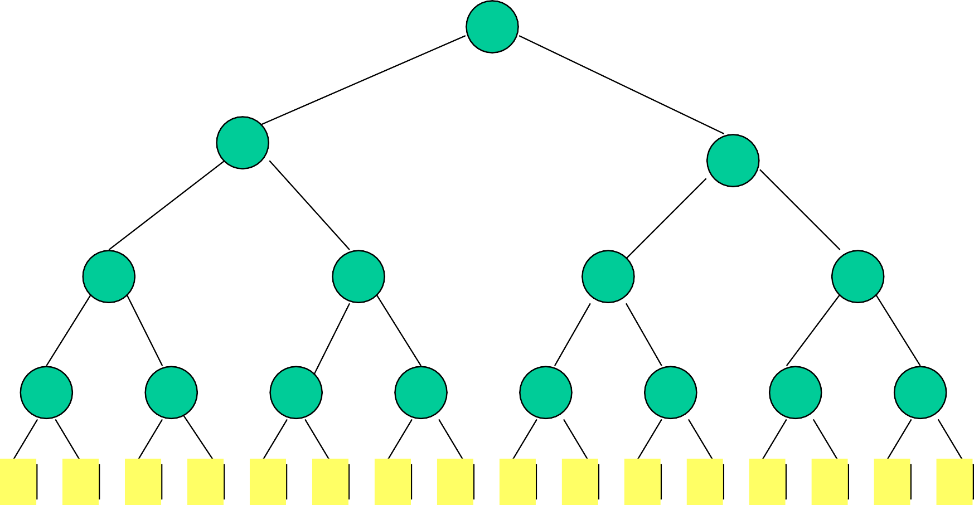1

1 2

3 1 2 2

3 6 1 3 2 4 2 5

4 3 6 8 1 5 7 3 2 6 9 4 5 2 5 8

height is log2 n (excludes player level)

# Complexity Of Initialize

* O(1) time to play match at each match node.
* n – 1 match nodes.
* O(n) time to initialize n-player winner tree.

# Winner Tree Operations

* Initialize
  + O(n) time
* Get winner
  + O(1) time
* Replace winner and replay
  + O(log n) time
  + More precisely Theta(log n)
* Tie breaker (player on left wins in case of a tie).

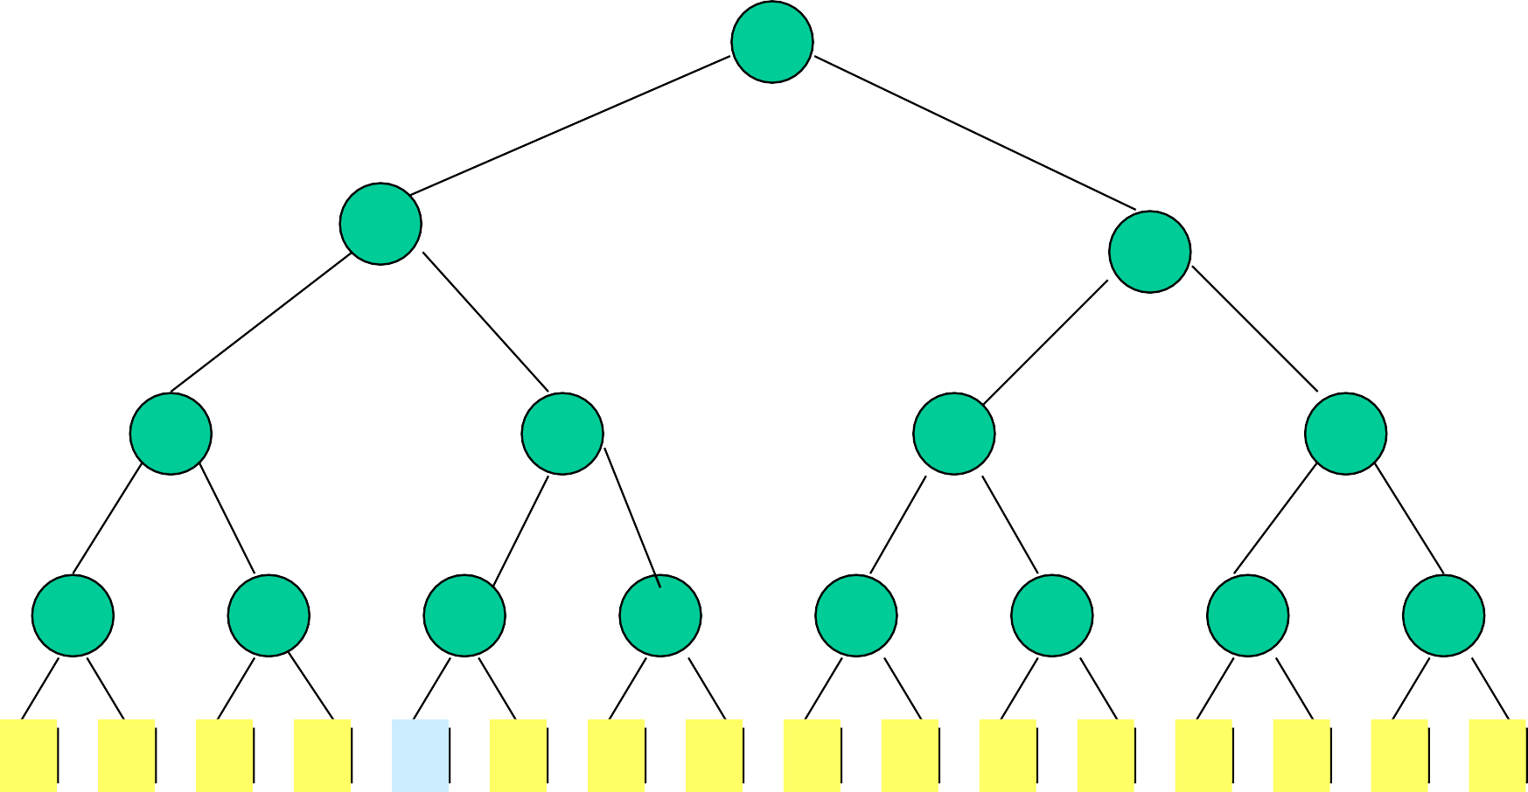1

1 2

3 1 2 2

3 6 1 3 2 4 2 5

4 3 6 8 1 5 7 3 2 6 9 4 5 2 5 8

Replace winner with 6.

1

1 2

3 1 2 2

3 6 1 3 2 4 2 5

4 3 6 8 6 5 7 3 2 6 9 4 5 2 5 8

Replay matches on path to root.

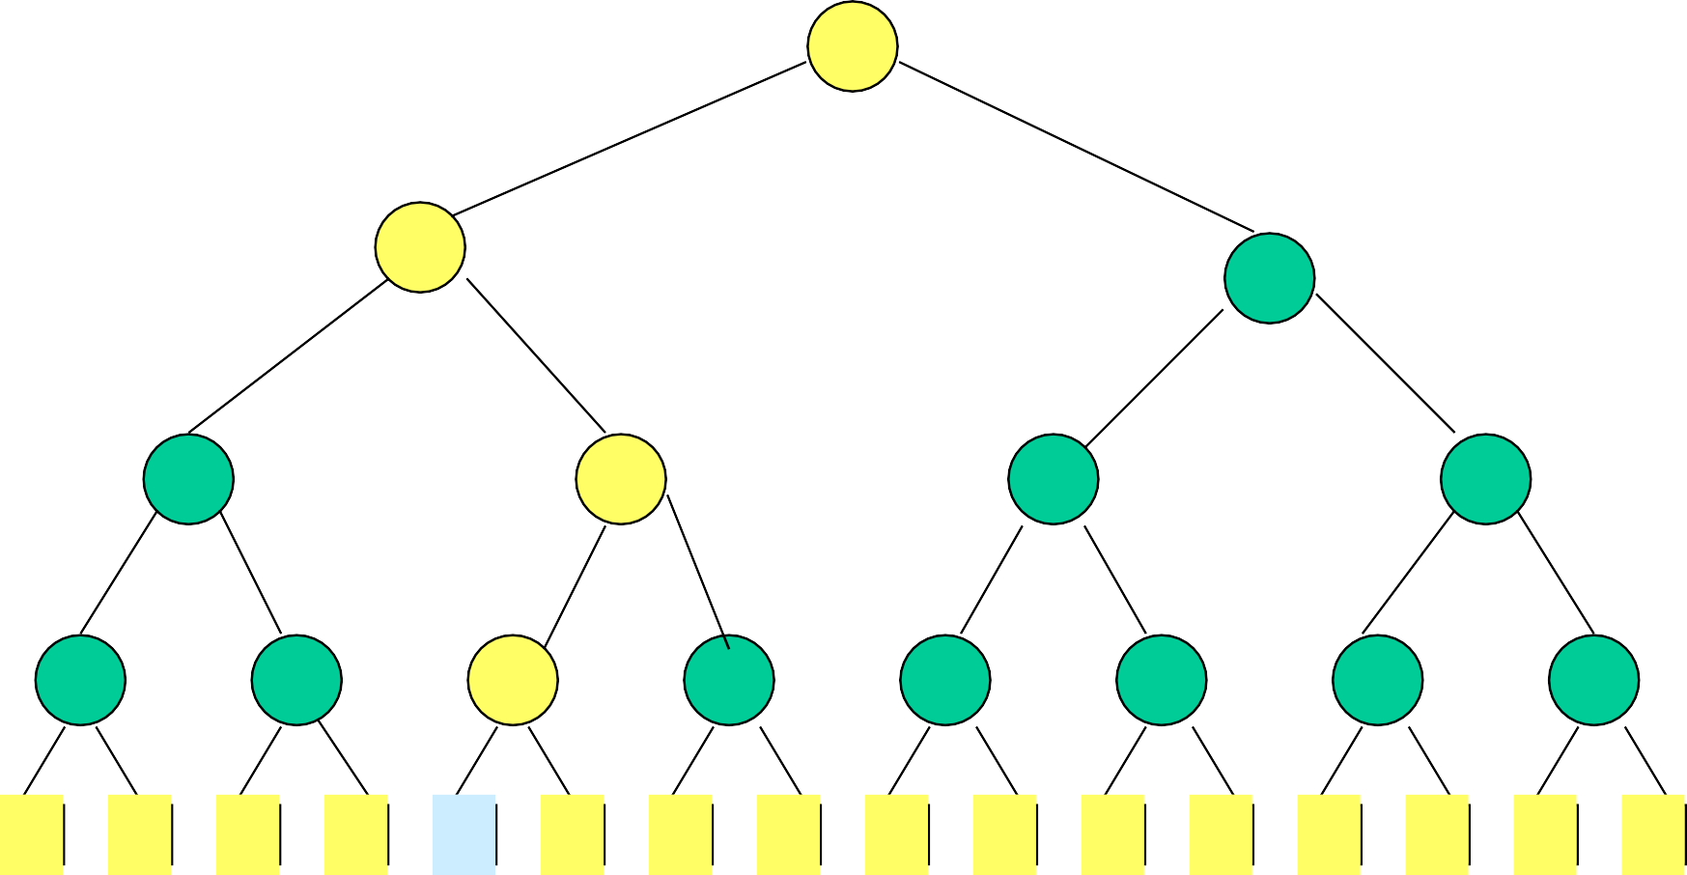1

1 2

3 1 2 2

3 6 1 3 2 4 2 5

4 3 6 8 6 5 7 3 2 6 9 4 5 2 5 8

Replay matches on path to root.

1

1 2

3 1 2 2

3 6 1 3 2 4 2 5

4 3 6 8 6 5 7 3 2 6 9 4 5 2 5 8

Opponent is player who lost last match played at this node.

# Loser Tree

Each match node stores the match loser rather than the match winner.

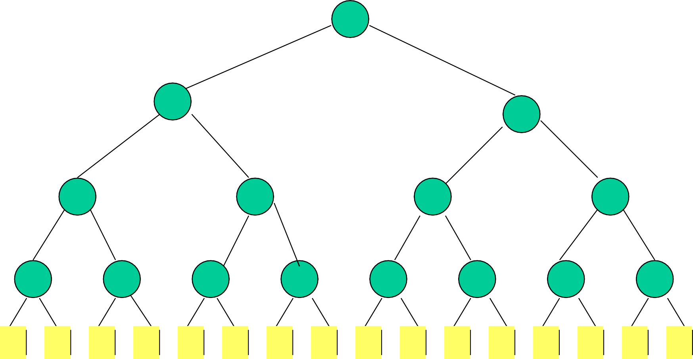3

4 8

4 3 6 8 1 5 7 3 2 6 9 4 5 2 5 8

3

6 1

4 8 5 7

4 3 6 8 1 5 7 3 2 6 9 4 5 2 5 8

# Min Loser Tree For 16 Players

1

3

6 3 2

4 8 5 7 6 9

4 3 6 8 1 5 7 3 2 6 9 4 5 2 5 8

# Min Loser Tree For 16 Players

1

3 2

6 3 4 2

4 8 5 7 6 9 5 8

4 3 6 8 1 5 7 3 2 6 9 4 5 2 5 8

# Min Loser Tree For 16 Players

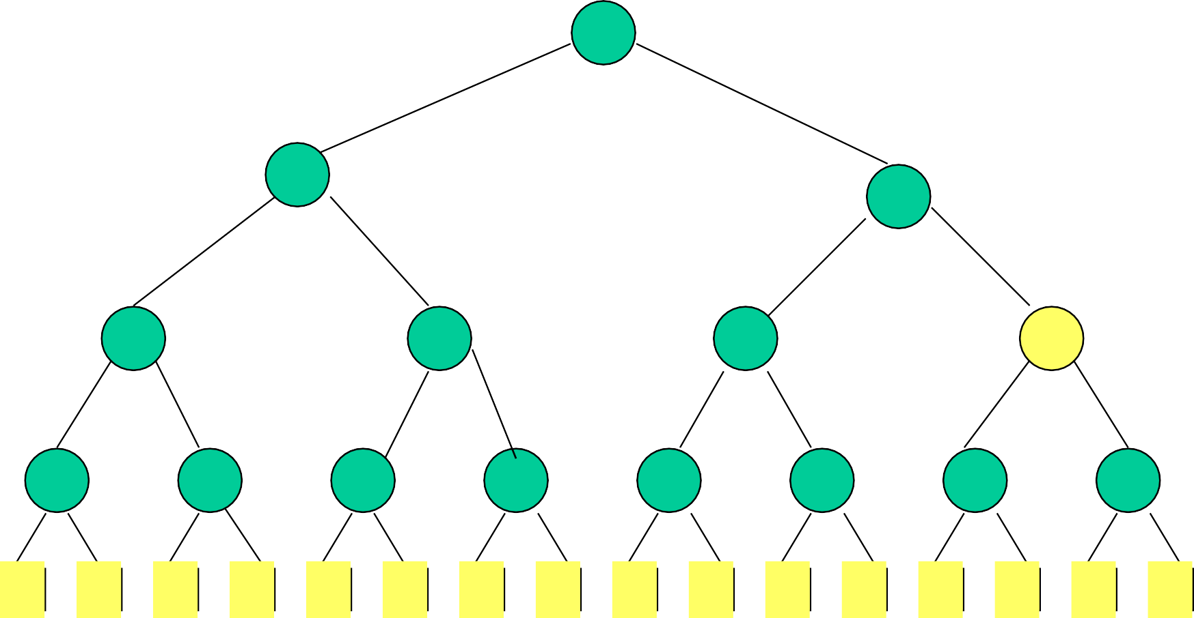1

3 2

6 3 4 5

4 8 5 7 6 9 5 8

4 3 6 8 1 5 7 3 2 6 9 4 5 2 5 8

# Min Loser Tree For 16 Players

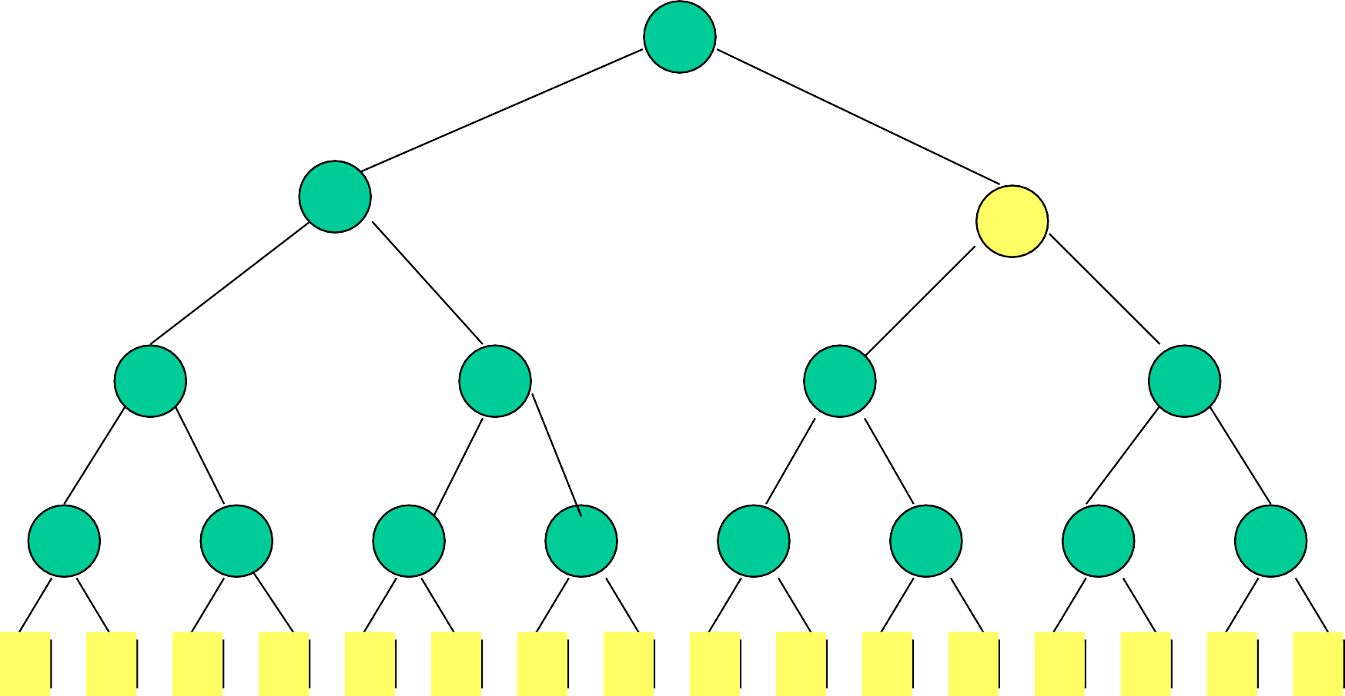1

3 2

6 3 4 5

4 8 5 7 6 9 5 8

4 3 6 8 1 5 7 3 2 6 9 4 5 2 5 8

# Min Loser Tree For 16 Players

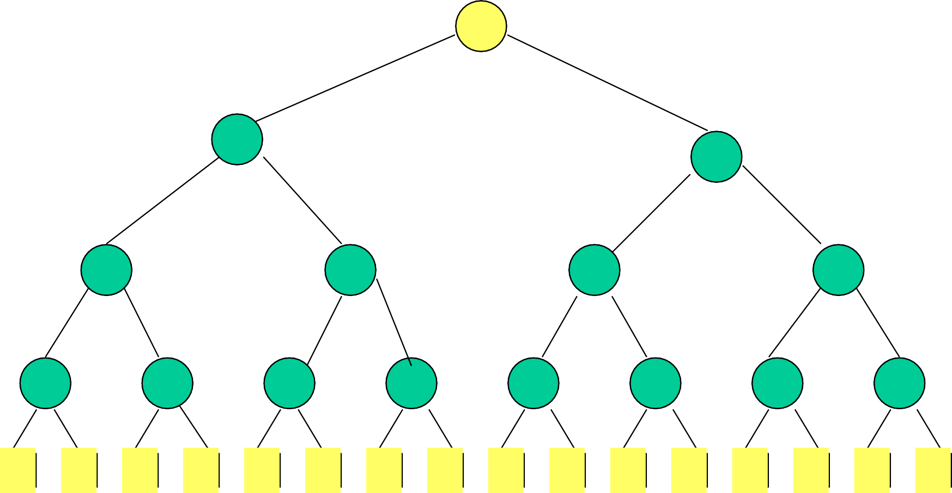2

3 2

6 3 4 5

4 8 5 7 6 9 5 8

4 3 6 8 1 5 7 3 2 6 9 4 5 2 5 8

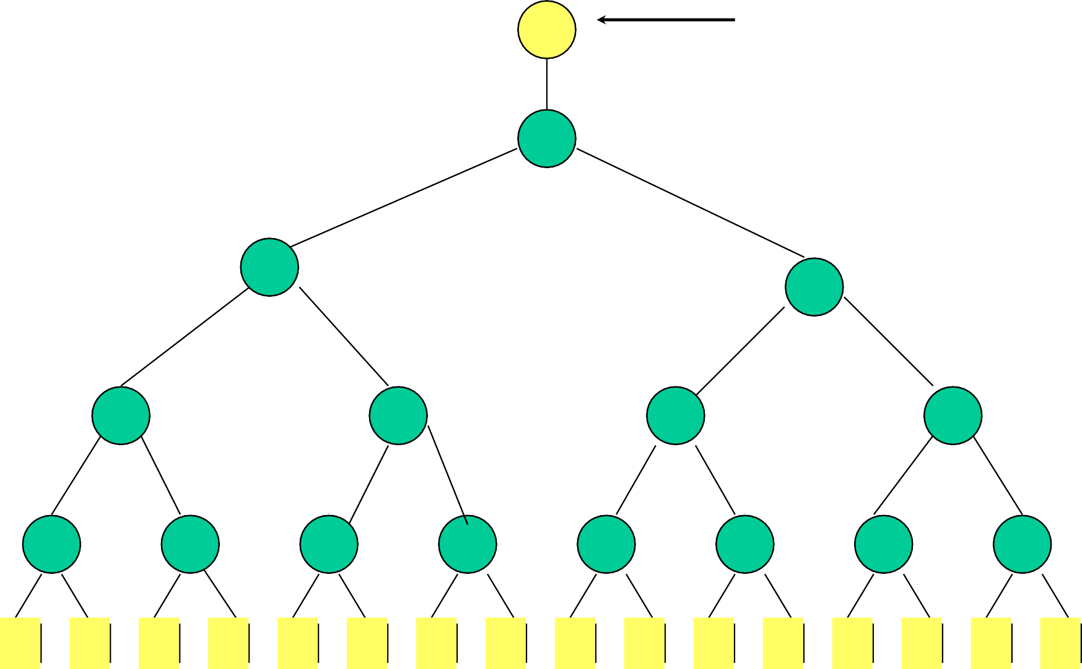1 Winner

2

3 2

6 3 4 5

4 8 5 7 6 9 5 8

4 3 6 8 1 5 7 3 2 6 9 4 5 2 5 8

# Complexity Of Loser Tree Initialize

* Start with 2 credits at each match node.
* Use one to pay for the match played at that node and the storing of the loser.
* Use the other to pay for the store of a left child winner.



* Total time is O(n).
* More precisely Theta(n).

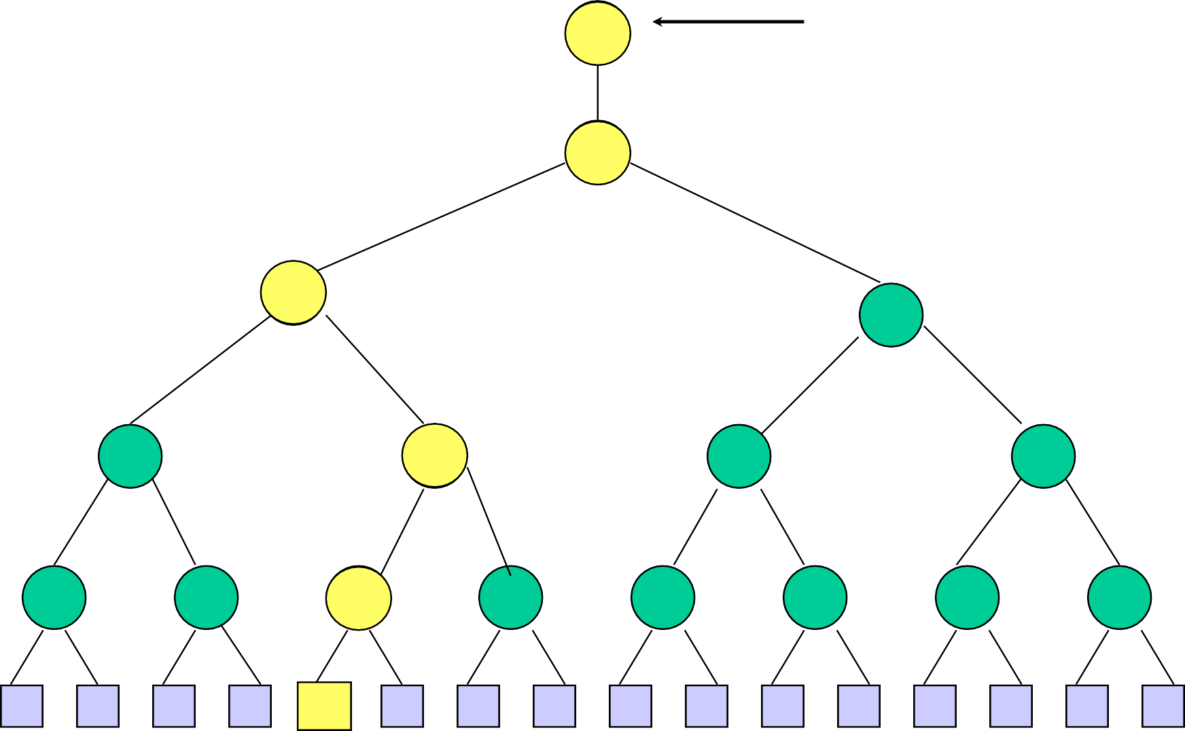21 Winner

32

**3** 2

6 53 4 5

4 8 65 7 6 9 5 8

4 3 6 8 6

1

5 7 3 2 6 9 4 5 2 5 8

Replace winner with 6 and replay matches.

# Complexity Of Replay

* + One match at each level that has a match node.
  + O(log n)
  + More precisely Theta(log n).

# Tournament Tree Applications

* + k-way merging of runs during an external merge sort.
  + Truck loading.
  + Run generation.
  + …

# Truck Loading





* + - n packages to be loaded into trucks
    - each package has a weight
    - each truck has a capacity of c tons
    - minimize number of trucks
* n items to be packed into bins
* each item has a size
* each bin has a capacity of c
* minimize number of bins

Truck loading is same as bin packing.

Truck is a bin that is to be packed (loaded). Package is an item/element.

Bin packing to minimize number of bins is NP-hard. Several fast heuristics have been proposed.

* + First Fit.
    - Bins are arranged in left to right order.
    - Items are packed one at a time in given order.
    - Current item is packed into leftmost bin into which it fits.
    - If there is no bin into which current item fits, start a new bin.
  + First Fit Decreasing.
    - Items are sorted into decreasing order.
    - Then first fit is applied.
  + Best Fit.
    - Items are packed one at a time in given order.
    - To determine the bin for an item, first determine set S

of bins into which the item fits.

* + - If S is empty, then start a new bin and put item into this new bin.
    - Otherwise, pack into bin of S that has least available

capacity.

* + Best Fit Decreasing.
    - Items are sorted into decreasing order.
    - Then best fit is applied.

# Performance

* + For first fit and best fit:

Heuristic Bins <= (17/10)(Minimum Bins) + 2

* + For first fit decreasing and best fit decreasing:

Heuristic Bins <= (11/9)(Minimum Bins) + 4

9

8 9

8 7 9 8

4 8 5 7 6 9 5 8

4 3 6 8 1 5 7 3 2 6 9 4 5 2 5 8

Item size = 7

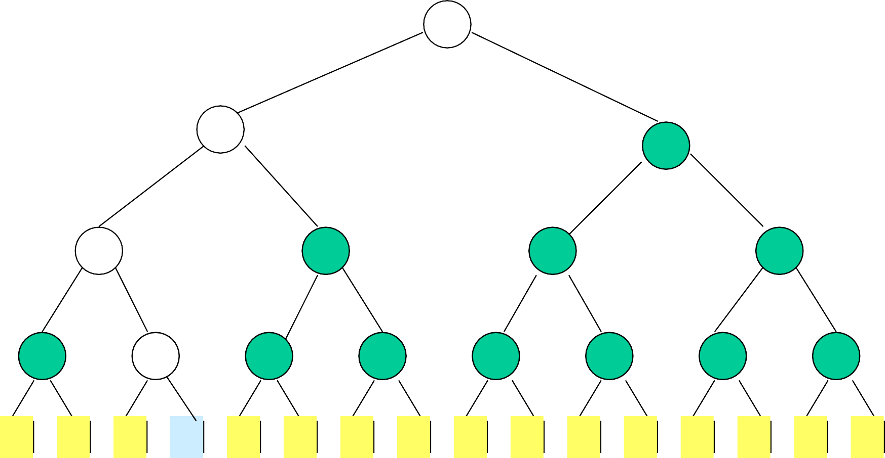9

7 9

6 7 9 8

4 6 5 7 6 9 5 8

4 3 6 1 1 5 7 3 2 6 9 4 5 2 5 8

# Complexity Of First Fit

O(n log n), where n is the number of items.

# Improve Run Generation

* Overlap input,output, and internal CPU work.
* Reduce the number of runs (equivalently, increase average run length).

DISK

MEMORY

DISK

# Internal Quick Sort

|  |  |  |  |  |  |  |  |  |  |  |
| --- | --- | --- | --- | --- | --- | --- | --- | --- | --- | --- |
| 6 | 2 | 8 | 5 | 11 | 10 | 4 | 1 | 9 | 7 | 3 |

Use 6 as the pivot (median of 3).

Input first, middle, and last blocks first. In-place partitioning.

|  |  |  |  |  |  |  |  |  |  |  |
| --- | --- | --- | --- | --- | --- | --- | --- | --- | --- | --- |
| 4 | 2 | 3 | 5 | 1 | 6 | 10 | 11 | 9 | 7 | 8 |

Input blocks from the ends toward the middle. Sort left and right groups recursively.

Can begin output as soon as leftmost block is ready.

# Alternative Internal Sort Scheme

DISK

Partition into 3 areas, each may be

more than 1 block in size.

DISK

|  |  |  |
| --- | --- | --- |
| A1 | A2 | A3 |

# Steady State Operation



Read from

disk

Write to

disk

Internal

sorting

* Synchronization is done when the current internal sort terminates.

# New Strategy

MEMORY

DISK

|  |  |
| --- | --- |
| Output 0 | Output 1 |
| Loser Tree | |
| Input 0 | Input 1 |

* + Use 2 input and 2 output buffers.

DISK

* + Rest of memory is used for a min loser tree.
    - Actually, 3 buffers adequate.

# Steady State Operation



Read from

disk

Write to

disk

Run

generation

* Synchronization is done when the active input buffer gets empty (the active output buffer will be full at this time).

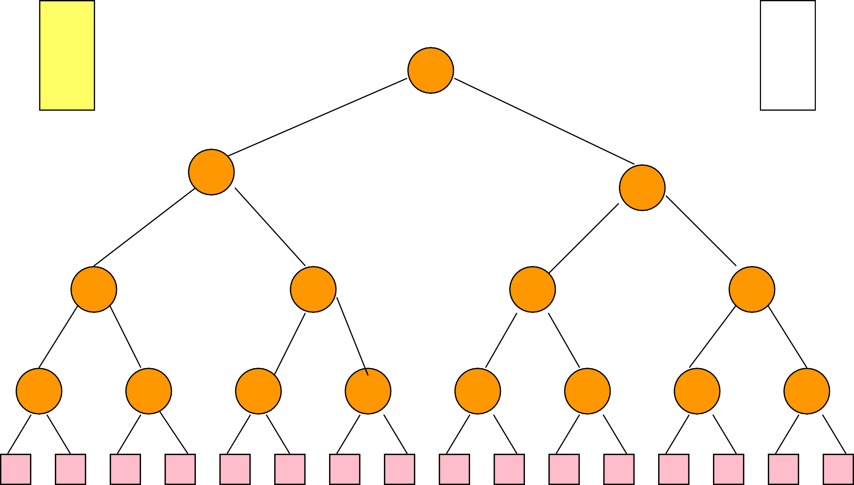O0 O1

3

4 8

4 3 6 8 1 5 7 3 2 6 9 4 5 2 5 8

I0 I1



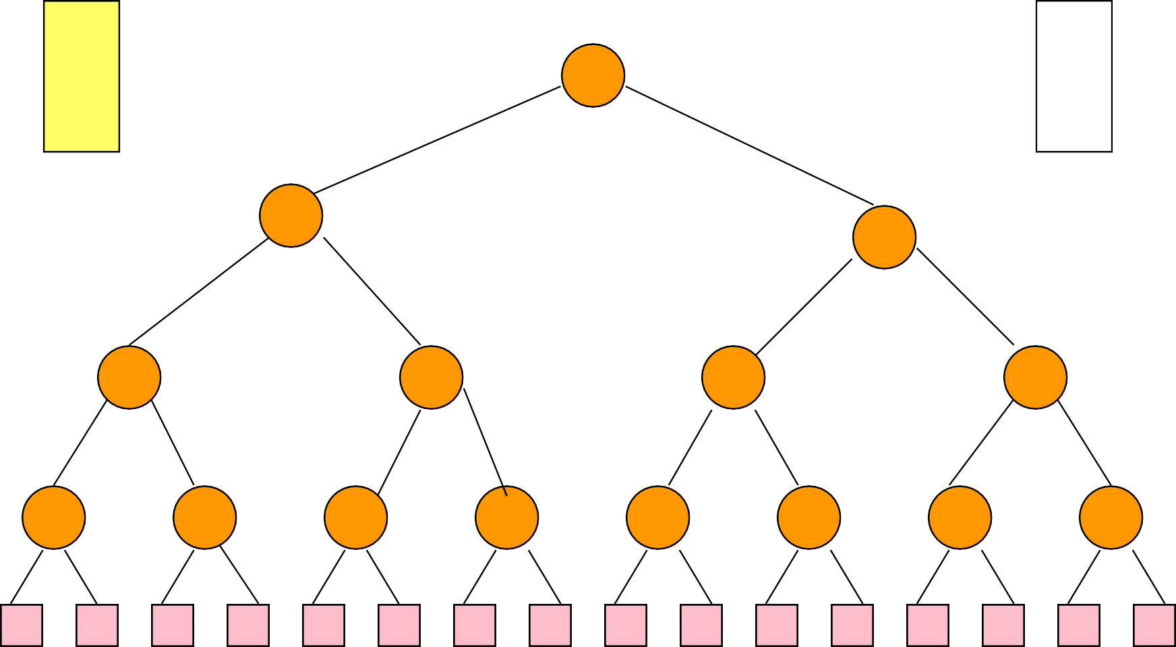O0 3 O1

6 1

4 8 5 7

4 3 6 8 1 5 7 3 2 6 9 4 5 2 5 8

I0 I1



1

O0 O1

3

6 3 2

4 8 5 7 6 9

4 3 6 8 1 5 7 3 2 6 9 4 5 2 5 8

I0 I1



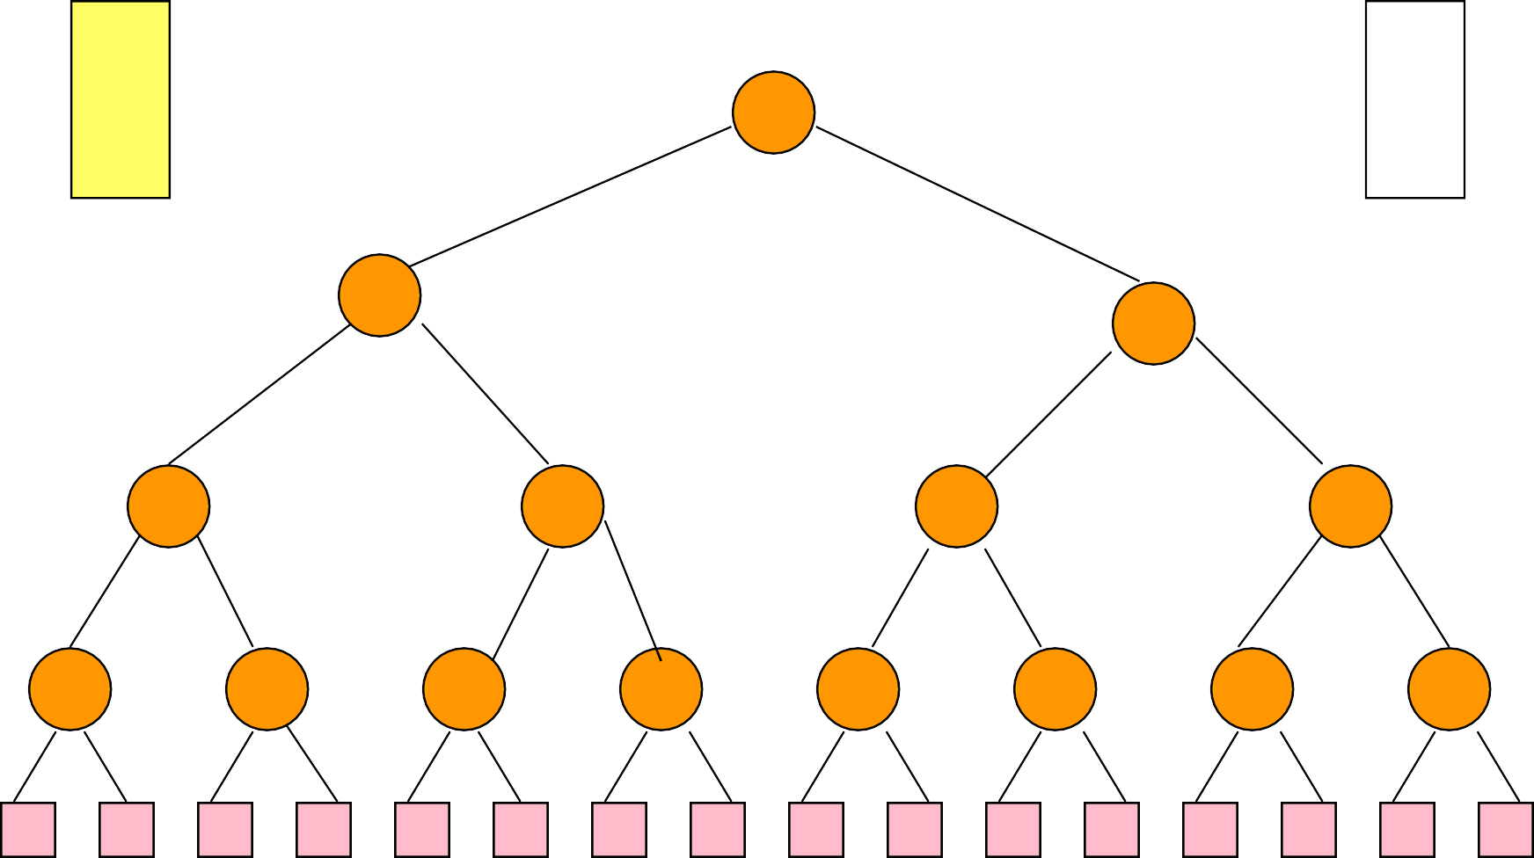1

O0 3 O1

2

6 3 4 2

4 8 5 7 6 9 5 8

4 3 6 8 1 5 7 3 2 6 9 4 5 2 5 8

I0 I1



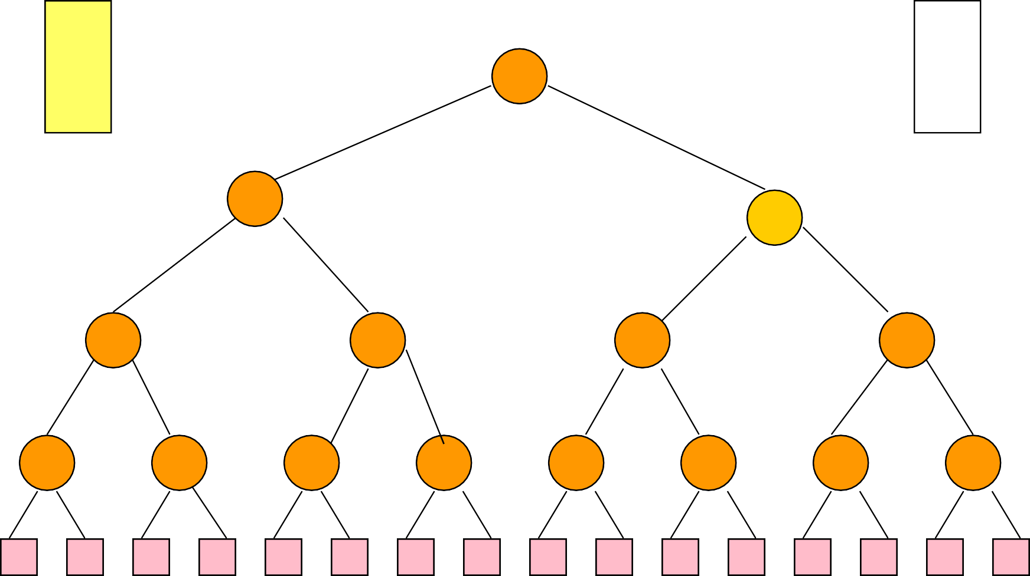1

O0 3 O1

2

6 3 4 5

4 8 5 7 6 9 5 8

4 3 6 8 1 5 7 3 2 6 9 4 5 2 5 8

I0 I1



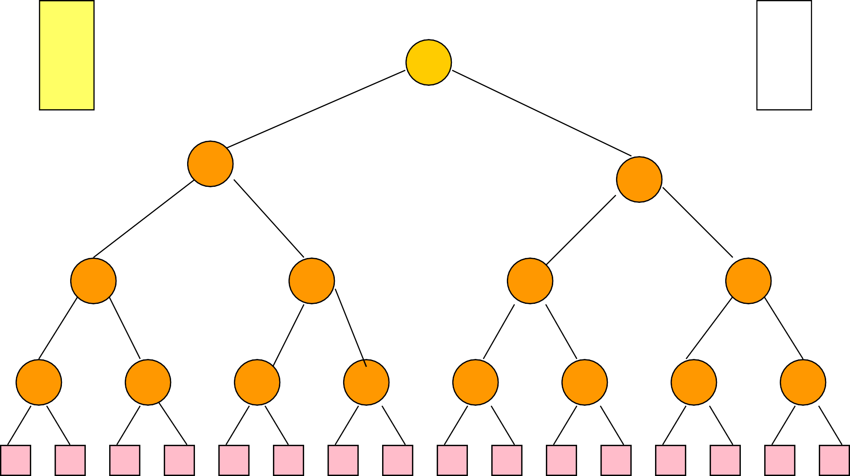2

O0 3 O1

2

6 3 4 5

4 8 5 7 6 9 5 8

4 3 6 8 1 5 7 3 2 6 9 4 5 2 5 8

I0 I1



# Generate Run 1



2

O0 3 O1

2

6 3 4 5

4 8 5 7 6 9 5 8

4 3 6 8 1 5 7 3 2 6 9 4 5 2 5 8

I0 I1



3

5

4



1

O0 3

# Generate Run 1

23

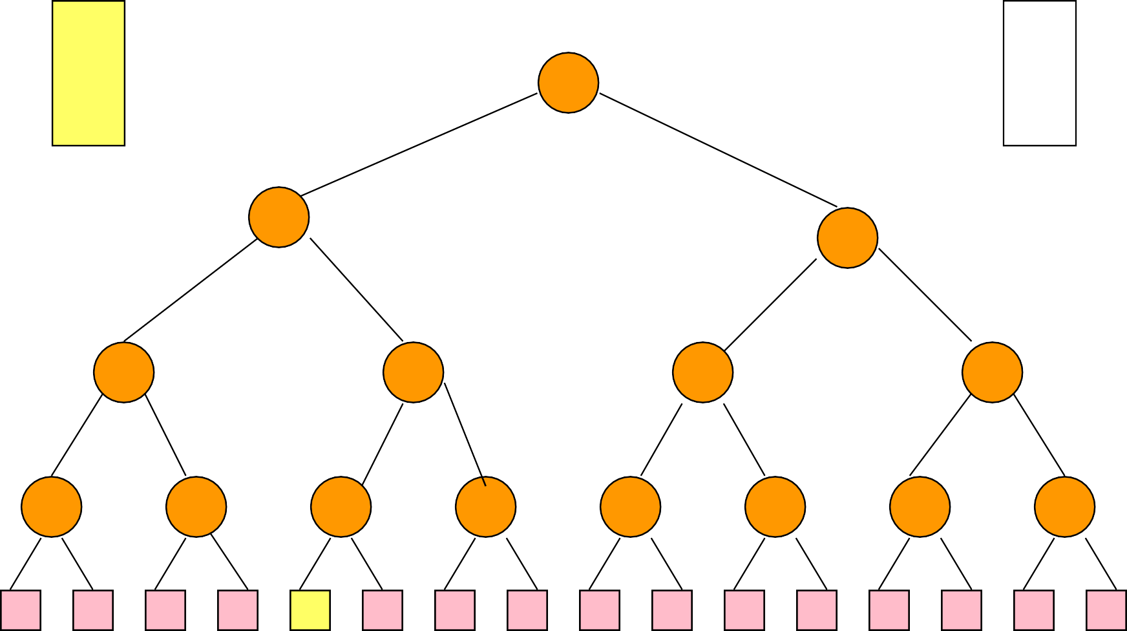

O1

2

6 3 4 5

4 8 5 7 6 9 5 8

4 3 6 8 3 5 7 3 2 6 9 4 5 2 5 8

I0 I1

3

5

4



1

2

O0 3

# Generate Run 1

3

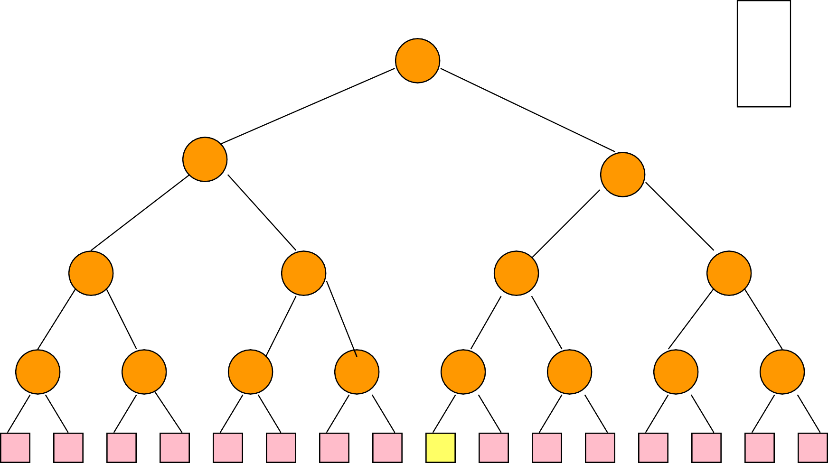

O1

42

6 3 45 5

4 8 5 7 6 9 5 8

4 3 6 8

3 5 7 3

5 6 9 4 5 2 5 8

I0 I1

3

5

4



1

2

2

O0 3

# Generate Run 1

3

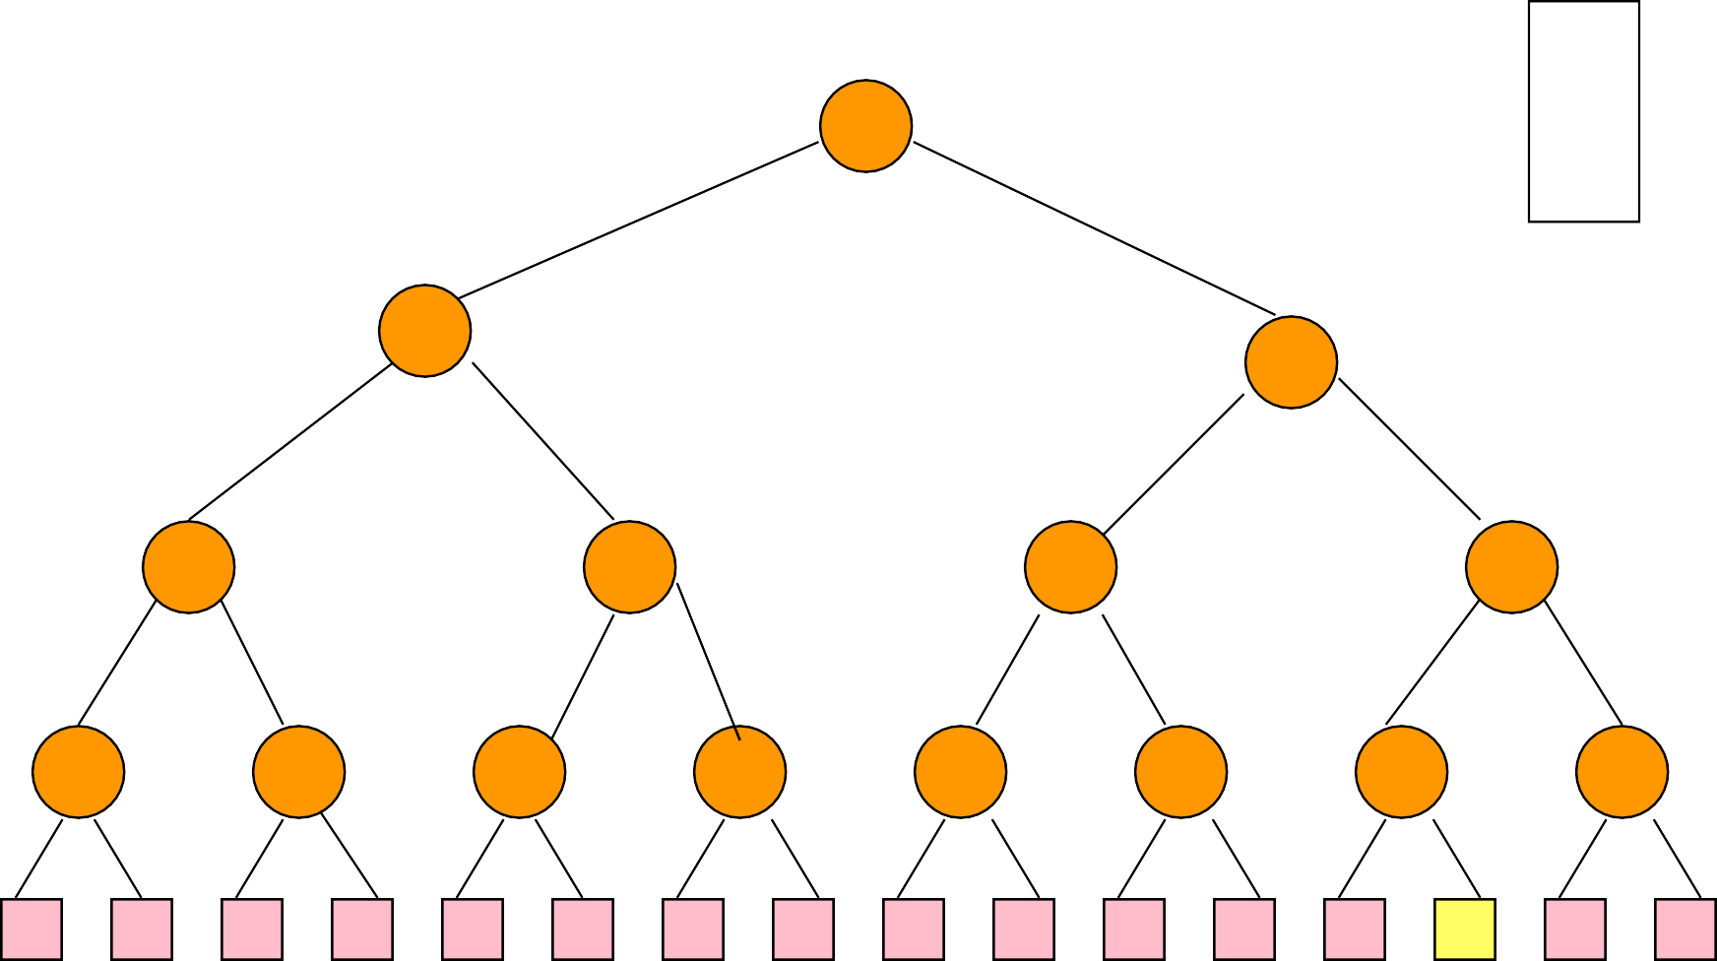

O1

42

6 3 45 5

4 8 5 7 6 9 5 8

4 3 6 8

3 5 7 3

5 6 9 4 5

4 5 8

I0 I1

3

5

4



3



1

2

2

O0 3 O1

42

6 3 45 5

4 8 5 7 6 9 5 8

4 3 6 8

3 5 7 3

5 6 9 4 5

4 5 8

I0 I1



1

9

2

# Continue With Run 1



1

2

2

34

O0 3 O1

4

6 3 45 5

4 8 5 7 6 9 5 8

4 3 6 8

3 5 7 3

5 6 9 4 5

4 5 8

I0 I1



1

9

2

# Continue With Run 1

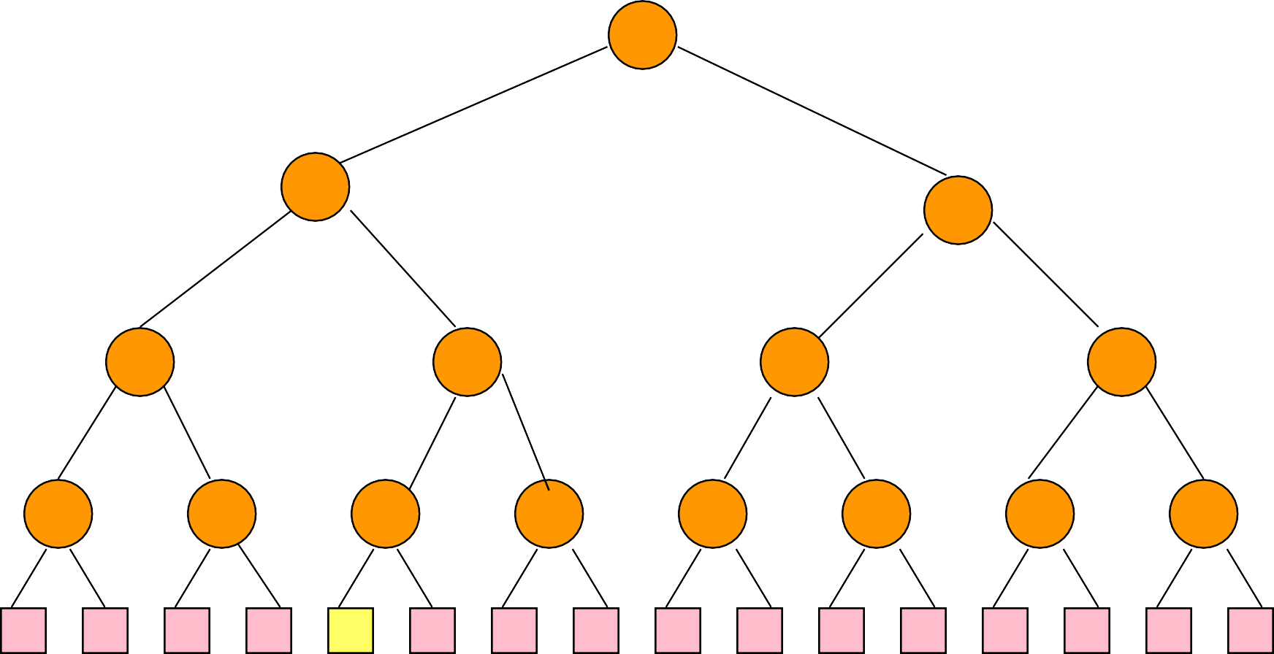

1

2

2

3

4

O0 3 O1

4

6 35 45 5

4 8 5**1** 7 6 9 5 8

4 3 6 8 **1**

5 7 3

5 6 9 4 5

4 5 8

I0 I1



1

9

2

# Continue With Run 1



3

3

1

2

2

4

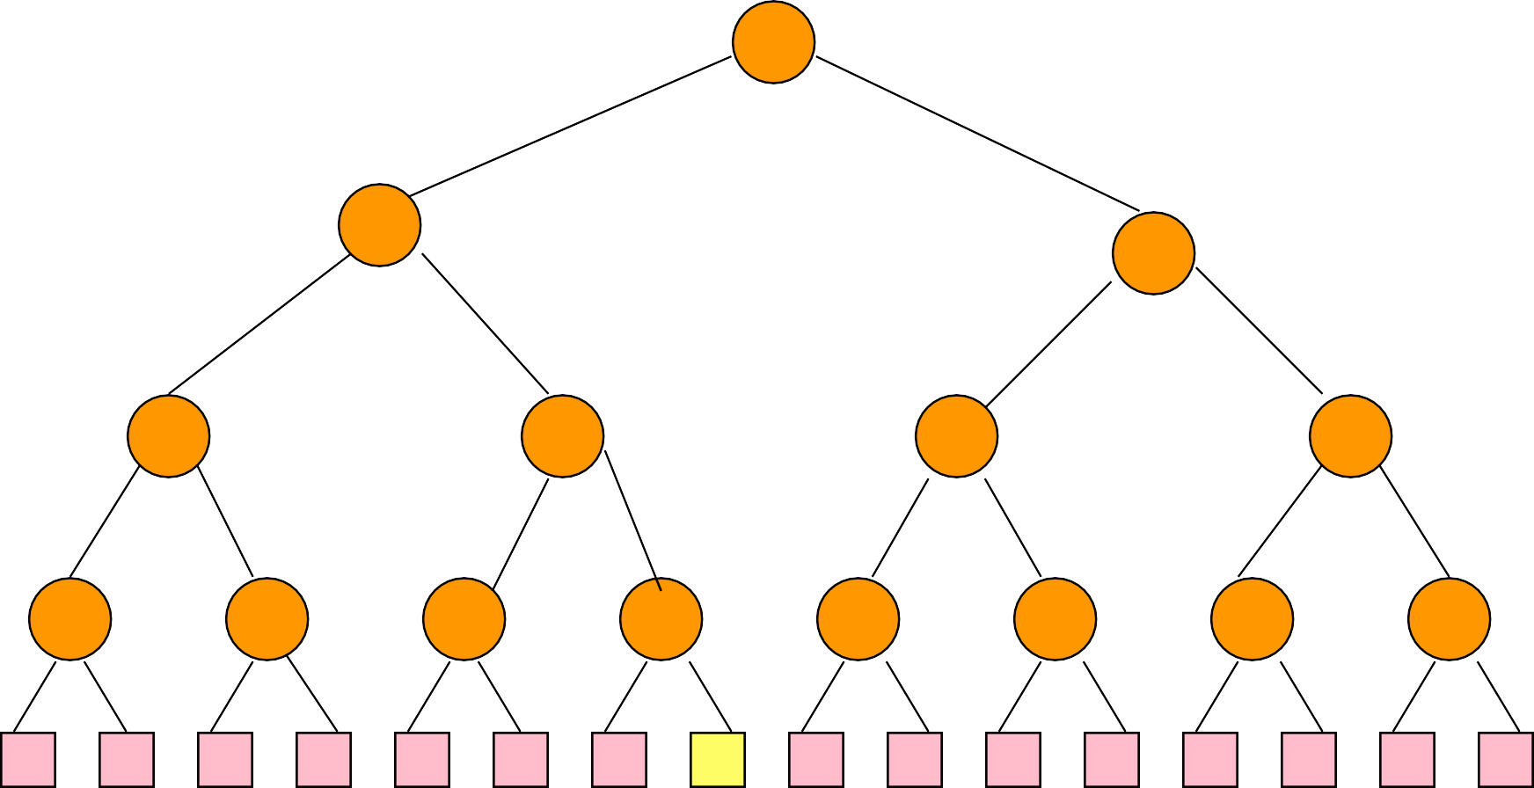

O0 35 O1

4

6 357 45 5

4 8 5**1** 79 6 9 5 8

4 3 6 8 **1** 5 7

9 5 6 9 4 5

4 5 8

I0 I1



1

9

2

# Continue With Run 1



3

3

3

1

2

2

4

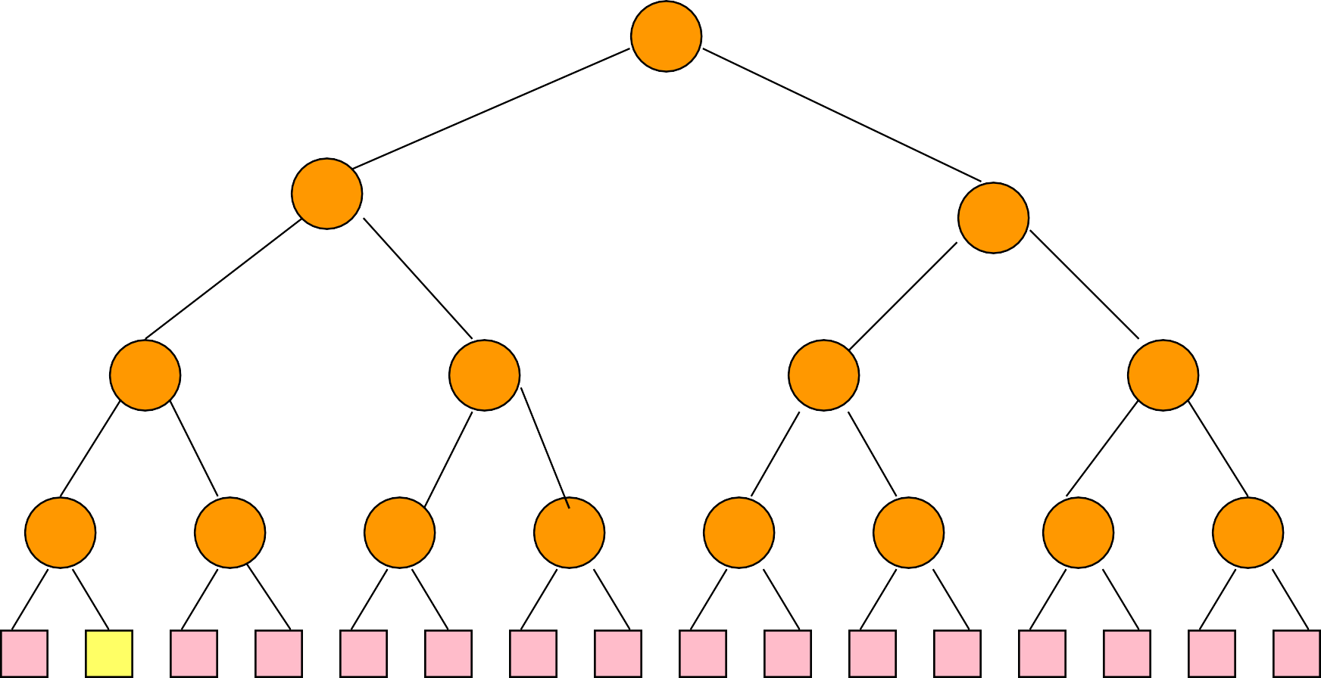

O0 35 O1

4

6 357 45 5

4 8 5**1** 79 6 9 5 8

4 **2** 6 8 **1** 5 7

9 5 6 9 4 5

4 5 8

I0 I1



1

9

2



4



3

3

3

O0 53 O1

4

6 357 45 5

4 8 5**1** 79 6 9 5 8

4 **2** 6 8 **1** 5 7

9 5 6 9 4 5

4 5 8

I0 I1



6

1

3

# Continue With Run 1



3

3

3

4

O0 53 O1

4

6 357 45 5

**2**4 8

5**1** 79

6 9 5 8

4 **2** 6 8 **1** 5 7

9 5 6 9 4 5

4 5 8

I0 I1



6

1

3

# Continue With Run 1



3

3

3

4

45

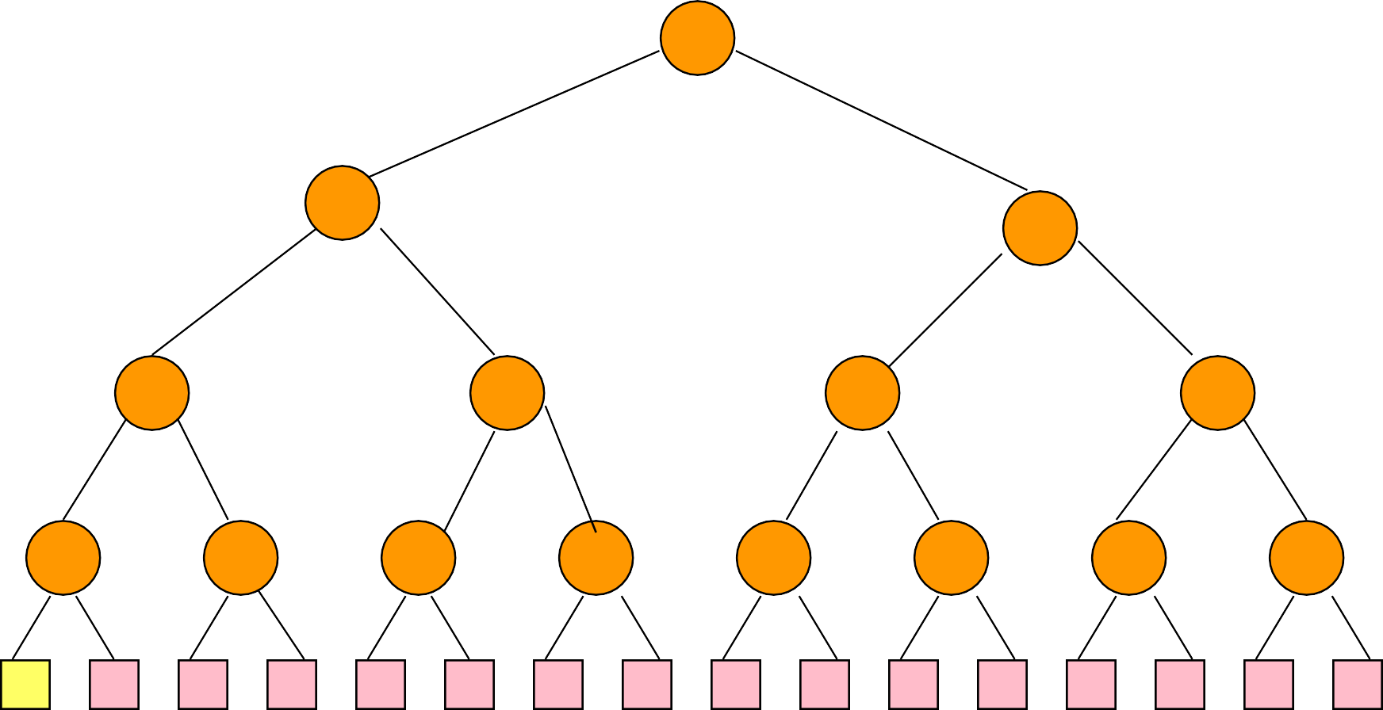

O0 653 O1

4

6 357 45 5

**2**4 8

5**1** 79

6 9 5 8

6 **2** 6 8 **1** 5 7

9 5 6 9 4 5

4 5 8

I0 I1

6

1

3



# Continue With Run 1



3

3

3

4

4

45

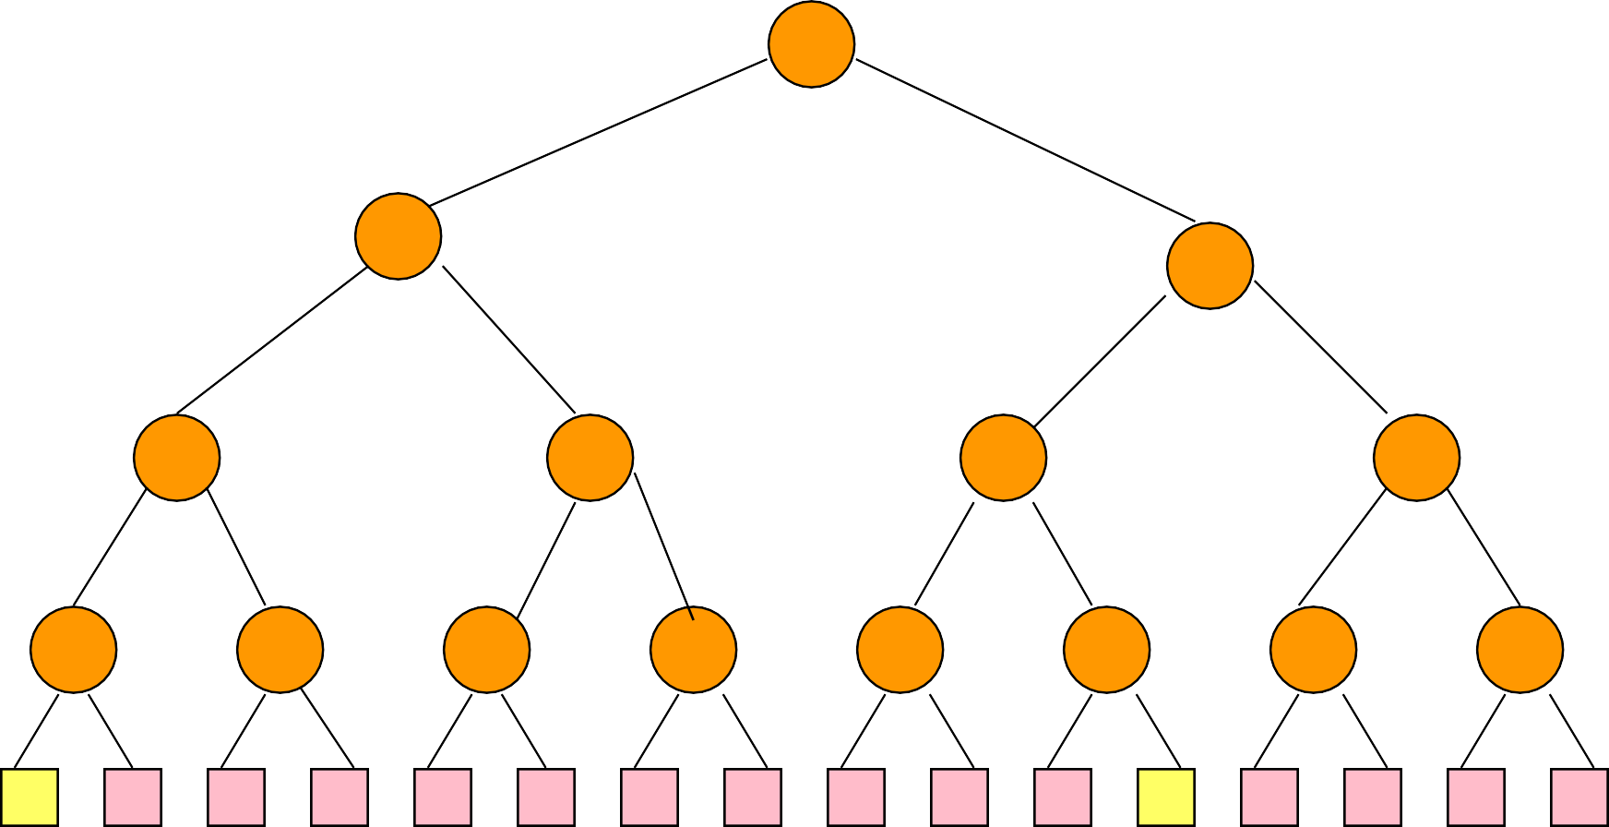

O0 653 O1

45

6 375 459 5

**2**4 8

5**1** 79

6 9**1** 5 8

6 **2** 6 8 **1** 5 7

9 5 6 9 **1** 5

4 5 8

I0 I1

6

1

3



* Let k be number of external nodes in the loser tree.
* Run size >= k.
* Sorted input => 1 run.
* Reverse of sorted input => n/k runs.
* Average run size is ~2k.
* Memory capacity = m records.
* Run size using fill memory, sort, and output run scheme = m.
* Use loser tree scheme.
  + Assume block size is b records.
  + Need memory for 3 buffers (3b records).
  + Loser tree k = m – 3b.
  + Average run size = 2k = 2(m – 3b).
  + 2k >= m when m >= 6b.
* Assume b = 100.

|  |  |  |  |  |
| --- | --- | --- | --- | --- |
| ***m*** | 500 | 1000 | 5000 | 10000 |
| ***k*** | 200 | 700 | 4700 | 9700 |
| ***2k*** | 400 | 1400 | 9400 | 19400 |

* Total internal processing time using fill memory, sort, and output run scheme

= O((n/m) m log m) = O(n log m).

* Total internal processing time using loser tree = O(n log k).
* Loser tree scheme generates runs that differ in their lengths.

# Merging Runs Of Different Length

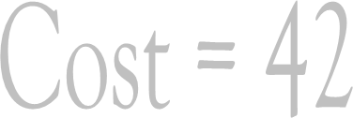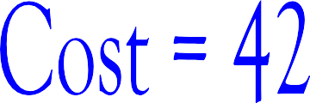

22

13

9

7

6

4

3

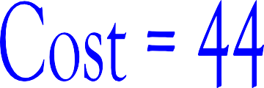

22

7

15

4

3

6

9

Optimal Merging Of Runs

22

7

15

4

3

6

9



22

13

9

7

6

4

3





WEPL(T) = (weight of external node i)

* (distance of node i from root of T)

WEPL(T) = 4 * 2 + 3*2 + 6*2 + 9*2

22

7

15

4

3

6

9

= 44



6

9

WEPL(T) = (weight of external node i)

* (distance of node i from root of T)



22

13

WEPL(T) = 4 * 3 + 3*3 + 6*2 + 9*1

= 42

7

4

3

# Other Applications

* Message coding and decoding.
* Lossless data compression.

# Message Coding & Decoding

* Messages M0, M1, M2, …, Mn-1 are to be transmitted.
* The messages do not change.
* Both sender and receiver know the messages.
* So, it is adequate to transmit a code that identifies the message (e.g., message index).
* Mi is sent with frequency fi.
* Select message codes so as to minimize transmission and decoding times.
  + n = 4 messages.
  + The frequencies are [2, 4, 8, 100].
  + Use 2-bit codes [00, 01, 10, 11].
  + Transmission cost = 2*2 + 4*2 + 8*2 + 100*2

= 228.

* + Decoding is done using a binary tree.

0

1

0

2

1

4

8

100

M0 M1 M2 M3

* Decoding cost = 2*2 + 4*2 + 8*2 + 100*2

= 228

= transmission cost

= WEPL

* + Every binary tree with n external nodes defines a code set for n messages.

0 1

8

100

0 1 M3

0 1 M2

2 4

M0 M1

* Decoding cost

= 2*3 + 4*3 + 8*2 + 100*1

= 134

= transmission cost

= WEPL

# Another Example

0 1

0 1 0 1

0 1 0 1 0 1 M9

M0 M1 M2 M3

M4 M5 M8

M6 M7

No code is a prefix of another!

* Alphabet = {a, b, c, d}.
* String with 10 as, 5 bs, 100 cs, and 900 ds.
* Use a 2-bit code.
  + a = 00, b = 01, c = 10, d = 11.
  + Size of string = 10*2 + 5*2 + 100*2 + 900*2

= 2030 bits.

* + Plus size of code table.
* Use a variable length code that satisfies prefix property (no code is a prefix of another).
  + a = 000, b = 001, c = 01, d = 1.
  + Size of string = 10*3 + 5*3 + 100*2 + 900*1

= 1145 bits.

* + Plus size of code table.
  + Compression ratio is approx. 2030/1145 = 1.8.

0

1

0

1

d

0

1

c

a b

* Decode 0001100101…
* addbc…
* Compression ratio is maximized when the decode tree has minimum WEPL.

# Huffman Trees

* + Trees that have minimum WEPL.
  + Binary trees with minimum WEPL may be constructed using a greedy algorithm.
  + For higher order trees with minimum WEPL, a preprocessing step followed by the greedy algorithm may be used.
  + Huffman codes: codes defined by minimum WEPL trees.
  + n = 5, w[0:4] = [2, 5, 4, 7, 9].

9

2

5

4

7

9

* + n = 5, w[0:4] = [2, 5, 4, 7, 9].

9

5

7

5

7

9

6

2

4

* + n = 5, w[0:4] = [2, 5, 4, 7, 9].

11

7

9

5

6

2

4

* + n = 5, w[0:4] = [2, 5, 4, 7, 9].

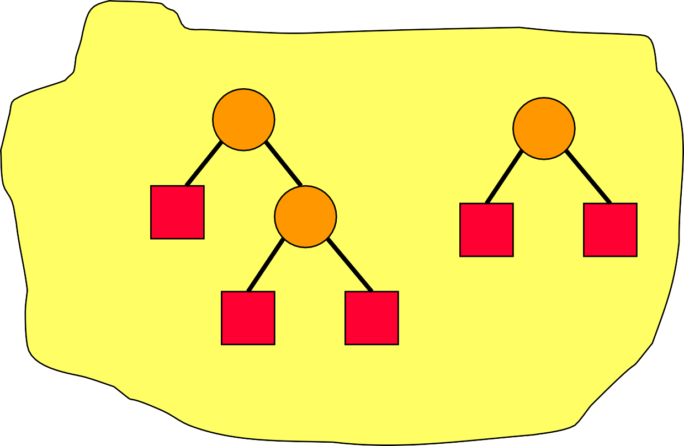

11

16

5

6

7

9

2

4

* + n = 5, w[0:4] = [2, 5, 4, 7, 9].

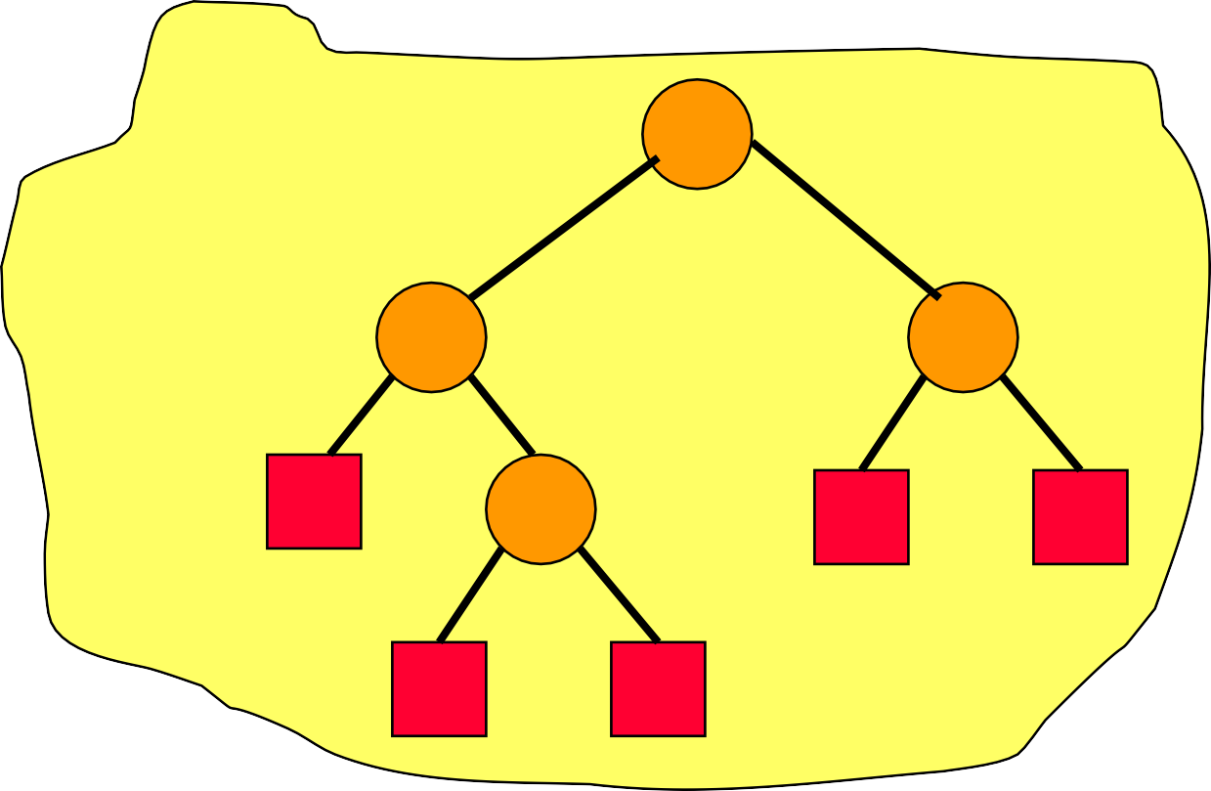

27

11

16

5

6

7

9

2

4

# Greedy Algorithm For Binary Trees

* Start with a collection of external nodes, each with one of the given weights. Each external node defines a different tree.
* Reduce number of trees by 1.
  + Remove 2 trees with minimum weight from the collection.
  + Combine them by making them children of a new root node.
  + The weight of the new tree is the sum of the weights of the individual trees.
  + Add new tree to tree collection.
* Repeat reduce step until only 1 tree remains.

# Data Structure For Tree Collection

* Operations are:
  + Initialize with n trees.
  + Remove 2 trees with least weight.
  + Insert new tree.
* Use a min heap.
* Initialize … O(n).
* 2(n – 1) remove min operations … O(n log n).
* n – 1 insert operations … O(n log n).
* Total time is O(n log n).
* Or, (n – 1) remove mins and (n – 1) change mins.

# Higher Order Trees

* Greedy scheme doesn’t work!
* 3-way tree with weights [3, 6, 1, 9].

19

10

9

3

6

19

4

6

9

3

Greedy Tree Cost = 29

1

1

Optimal Tree Cost = 23

# Cause Of Failure

19

10 0 9

3 6

Greedy Tree Cost = 29

* One node is not a 3-way node.

1

* A 2-way node is like a 3-way node, one of whose children has a weight of 0.
* Must start with enough runs/weights of length 0 so that all nodes are 3-way nodes.

# How Many Length 0 Runs To Add?

* k-way tree, k > 1.
* Initial number of runs is r.
* Add least q >= 0 runs of length 0.
* Each k-way merge reduces the number of runs by k – 1.
* Number of runs after s k-way merges is r + q – s(k – 1)
* For some positive integer s, the number of remaining runs must become 1.

# How Many Length 0 Runs To Add?

* So, we want

r + q – s(k–1) = 1

for some positive integer s.

* So, r + q – 1 = s(k – 1).
* Or, (r + q – 1) mod (k – 1) = 0.
* Or, r + q – 1 is divisible by k – 1.
  + This implies that q < k – 1.
* (r – 1) mod (k – 1) = 0 => q = 0.
* (r – 1) mod (k – 1) != 0 =>

q = k –1 – (r – 1) mod (k – 1).

* Or, q = (1 – r) mod (k – 1).

# Examples

* k = 2.
  + q = (1 – r) mod (k – 1) = (1 – r) mod 1 = 0.
  + So, no runs of length 0 are to be added.
* k = 4, r = 6.
  + q = (1 – r) mod (k – 1) = (1 – 6) mod 3

= (–5)mod 3

= (6 – 5) mod 3

= 1.

* + So, must start with 7 runs, and then apply greedy method.
* Reduce number of merge passes.
  + Use higher order merge.
  + Number of passes

= ceil(logk(number of initial runs)) where k is the merge order.

* More generally, a higher-order merge reduces the cost of the optimal merge tree.
* Overlap input, output, and internal merging.

DISK

DISK

MEMORY

# Steady State Operation



Read from

disk

Write to

disk

Merge

Partitioning Of Memory

MEMORY

DISK

|  |  |  |  |  |  |
| --- | --- | --- | --- | --- | --- |
| O0 | | O1 | |  | |
| Loser Tree | | | | | |
| I0 | I1 | | … | | Ib |

* Need exactly 2 output buffers.

DISK

* Need at least k+1 (k is merge order) input buffers.
* 2k input buffers suffice.

# Number Of Input Buffers

* + When 2 input buffers are dedicated to each of the k runs being merged, 2k buffers are not enough!
  + Input buffers must be allocated to runs on an as needed basis.

# Buffer Allocation

* When ready to read a buffer load, determine which run will exhaust first.
  + Examine key of the last record read from each of the k runs.
  + Run with smallest last key read will exhaust first.
  + Use an enforceable tie breaker.
* Next buffer load of input is to come from run that will exhaust first, allocate an input buffer to this run.

# Buffer Layout

Output buffers

F0 F1 F2 F3 F4 F5 F6 F7 F8



Input buffer queues k=9

R0 Read

Pool of free input buffers

R1

R2

R3

R4

R5

R6

R7

R8

Buffer

# Initialize To Merge k Runs

* Initialize k queues of input buffers, 1 queue per run, 1 buffer per run.
* Input one buffer load from each of the k runs.
* Put k – 1 unused input buffers into pool of free buffers.
* Set activeOutputBuffer = 0.
* Initiate input of next buffer load from first run to exhaust. Use remaining unused input buffer for this input.

# The Method kWayMerge

* k-way merge from input queues to the active output buffer.
* Merge stops when either the output buffer gets full or when an end-of-run key is merged into the output buffer.
* If merge hasn’t stopped and an input buffer gets empty, advance to next buffer in queue and free empty buffer.

# Merge k Runs

repeat

kWayMerge;

wait for input/output to complete;

add new input buffer (if any) to queue for its run; determine run that will exhaust first;

if (there is more input from this run) initiate read of next block for this run;

initiate write of active output buffer; activeOutputBuffer = 1 – activeOutputBuffer;

until end-of-run key merged;

* k-way merge from input queues to the active output buffer.



* Merge stops when either the output buffer gets full or when an end-of-run key is merged into the output buffer.
* If merge hasn’t stopped and an input buffer gets empty, advance to next buffer in queue and free empty buffer. There may be no next buffer in the queue.

repeat



kWayMerge;

wait for input/output to complete;

add new input buffer (if any) to queue for its run; determine run that will exhaust first;

if (there is more input from this run)

initiate read of next block for this run;

initiate write of active output buffer;

There may be no free input buffer to read into.

activeOutputBuffer = 1 – activeOutputBuffer;

until end of run key merged;

* If merge hasn’t stopped and an input buffer gets empty, advance to next buffer in queue and free empty buffer. There may be no next buffer in the queue.



* + If this type of failure were to happen, using two different and valid analyses, we will end up with inconsistent counts of the amount of data available to kWayMerge.
  + Data available to kWayMerge is data in
    - Input buffer queues.
    - Active output buffer.
* Excludes data in buffer being read or written.

repeat

# No Next Buffer In Queue

kWayMerge;

wait for input/output to complete;

add new input buffer (if any) to queue for its run; determine run that will exhaust first;

if (there is more input from this run) initiate read of next block for this run;

initiate write of active output buffer; activeOutputBuffer = 1 – activeOutputBuffer;

until end-of-run key merged;

* Exactly k buffer loads available to kWayMerge.
* If merge hasn’t stopped and an input buffer gets empty, advance to next buffer in queue and free empty buffer. There may be no next buffer in the queue.



* Alternative analysis of data available to kWayMerge at time of failure.
  + < 1 buffer load in active output buffer
  + <= k – 1 buffer loads in remaining k – 1 queues
  + Total data available to k-way merge is < k buffer loads.

There may be no free input buffer to read into.



initiate read of next block for this run;

* Suppose there is no free input buffer.
* One analysis will show there are exactly k + 1 buffer loads in memory (including newly read input buffer) at time of failure.
* Another analysis will show there are > k + 1 buffer loads in memory at time of failure.
* Note that at time of failure there is no buffer being read or written.

repeat

# No Free Input Buffer

kWayMerge;

wait for input/output to complete;

add new input buffer (if any) to queue for its run; determine run that will exhaust first;

if (there is more input from this run) initiate read of next block for this run;

initiate write of active output buffer; activeOutputBuffer = 1 – activeOutputBuffer;

until end-of-run key merged;

* + Exactly k + 1 buffer loads in memory.

There may be no free input buffer



initiate read of next block for this run;

to read into.

* Alternative analysis of data in memory.
  + 1 buffer load in the active output buffer.
  + 1 input queue may have an empty first buffer.
  + Remaining k – 1 input queues have a nonempty first buffer.
  + Remaining k input buffers must be in queues and full.
  + Since k > 1, total data in memory is > k + 1 buffer loads.

# Minimize Wait Time For I/O To Complete

Time to fill an output buffer

* time to read a buffer load
* time to write a buffer load

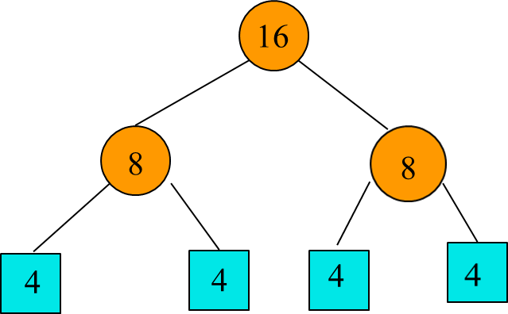

Change

if (there is more input from this run) initiate read of next block for this run;

to

if (there is more input from this run) initiate read of next block for this run;

else

initiate read of a block for the next k-way merge if on current read disk;

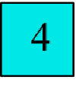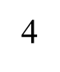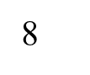

16

8

4

Using 1 output and k input buffers (k is merge order) and1 disk

64tIO + 32tIM



16

8

4

Using 2 output and 2k input buffers (k is merge order) and 2 disks

~38tIO

# External Merge Sort Steps

* Run Generation
  + Memory load scheme
  + Loser tree
* Merge Sequence For Runs & Run Distribution
  + Huffman Trees
  + Runs for external nodes on even levels on one disk; others on second disk if you have 2 disks
* Run merging
  + Loser tree
  + Double buffering if you have two disks

# Double-Ended Priority Queues

* Primary operations
  + Insert
  + Remove Max
  + Remove Min
* Note that a single-ended priority queue supports just one of the above remove operations.

# General Methods

* Dual min and max single-ended priority queues.
* Correspondence based min and max single- ended priority queues.

# Specialized Structures

* Symmetric min-max heaps.
* Min-max heaps.
* Deaps.
* Interval heaps.

…

# Dual Single-Ended Priority Queues

* Use a min and a max single-ended priority queue.
* Single-ended priority queue also must support an arbitrary remove.
* Each element is in both single-ended priority queues.
* Each priority queue node has a pointer to the node in the other priority queue that has the same element.

# 9-Element Example

1

4

2

5

7

9

3

8

6

9

6

8

5

1

4

7

2

3

Min Heap

Max Heap

* Only 5 of 9 two-way pointers shown.
* Insert, remove min, remove max, initialize.
* Operation cost is more than doubled relative to heap.
* Space for 2n nodes.

# Correspondence Structures

* Use a min and a max single-ended priority queue.
* At most 1 element is in a buffer.
* Remaining elements are in the single-ended priority queues, which may be of different size.
* No element is in both the min and max single-ended priority queue.
* Establish a correspondence between the min and max single-ended priority queues.
  + Total correspondence.
  + Leaf correspondence.
* Single-ended priority queue also must support an arbitrary remove.

# Total Correspondence

* The min- and max-priority queues are of the same size.
* Each element of the min priority queue is paired with a different and >= element in the max priority queue.

# Total Correspondence Example

1

20

5

9

10

18

14

17

2

7

Min Heap

Buffer = 12

Max Heap

# Insert

1

20

5

9

10

18

14

17

2

7

Min Heap

Buffer = 12

Max Heap

* Buffer empty => place in buffer.
* Else, insert smaller of new and buffer elements into min priority queue and larger into max priority queue; establish correspondence between the 2 elements.

# Remove Min

1

20

5

9

10

18

14

17

2

7

Min Heap

Buffer = 12

Max Heap

* Buffer is min => empty buffer.
* Else, remove min from min PQ as well as corresponding element from max PQ; reinsert corresponding element.

# Leaf Correspondence

* + Min- and max-priority queues may have different size.
  + Each leaf element of the min priority queue is paired with a different and >= element in the max priority queue.
  + Each leaf element of the max priority queue is paired with a different and <= element in the min priority queue.

# Added Restrictions

* When an element is inserted into a single-ended PQ, only the newly inserted element can become a new leaf.
* When an element is deleted from a single-ended PQ, only the parent of the deleted element can become a new leaf.
* Min and max heaps do not satisfy these restrictions. So, leaf correspondence is harder to implement using min and max heaps.

# Leaf Correspondence Example

1

20

5

3

10

18

14

17

6

7

Min Heap

Buffer = 12

Max Heap

1

20

5

3

10

18

14

17

6

7

Min Heap

Buffer = 12

Max Heap

* Buffer empty => place in buffer.
* Else, insert smaller of new and buffer elements into min priority queue; insert larger into max priority queue only if smaller one is a leaf.

1

20

5

3

10

18

14

17

6

7

Min Heap

Buffer = 12

Max Heap

* Case when min and/or max heap originally have an even number of elements is more involved, because a nonleaf may become a leaf. See reference.

# Remove Min

1

20

5

3

10

18

14

17

6

7

Min Heap

Buffer = 12

Max Heap

* Buffer is min => empty buffer.
* Else, remove min from min PQ as well as corresponding element (if any and a leaf) from max PQ; reinsert removed corresponding element (see reference for details).

# Interval Heaps

* Complete binary tree.
* Assume not empty.
* Each node (except possibly last one) has 2 elements.
* Last node has 1 or 2 elements.
* Let a and b be the elements in a node P, a <= b.
* [a, b] is the interval represented by P.
* The interval represented by a node that has just one element a is [a, a].
* The interval [c, d] is contained in interval [a, b] iff a <= c <= d <= b.
* In an interval heap each node’s (except for root)

interval is contained in that of its parent.

# Interval

a b

c d

* + [c,d] is contained in [a,b]
  + a <= c
  + d <= b

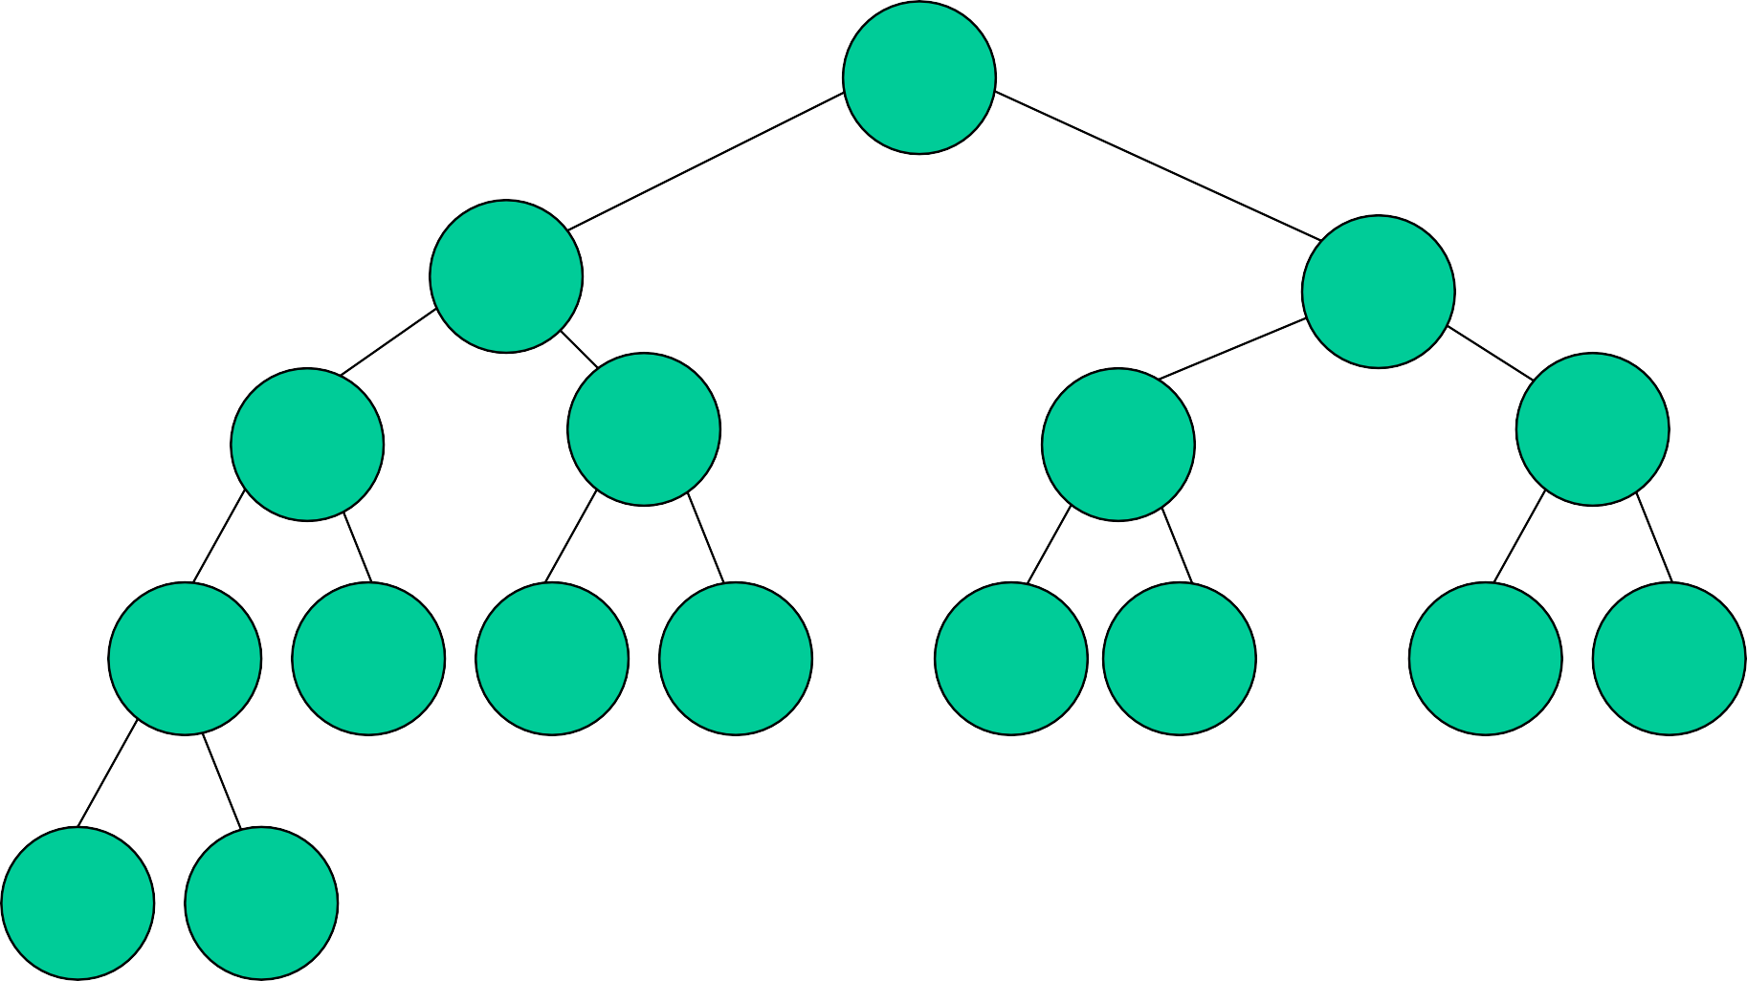10,90

15,80 30,60

20,70

15,20

45,60

35,50

25,60 30,50 16,19 17,17 50,55 47,58 40,45 40,43

28,55 35

Left end points define a min heap. Right end points define a max heap.

10,90

15,80 30,60

20,70

15,20

45,60

35,50

25,60 30,50 16,19 17,17 50,55 47,58 40,45 40,43

28,55 35

Min and max elements are in the root. Store as an array.

Height is ~log2 n.

# Insert An Element

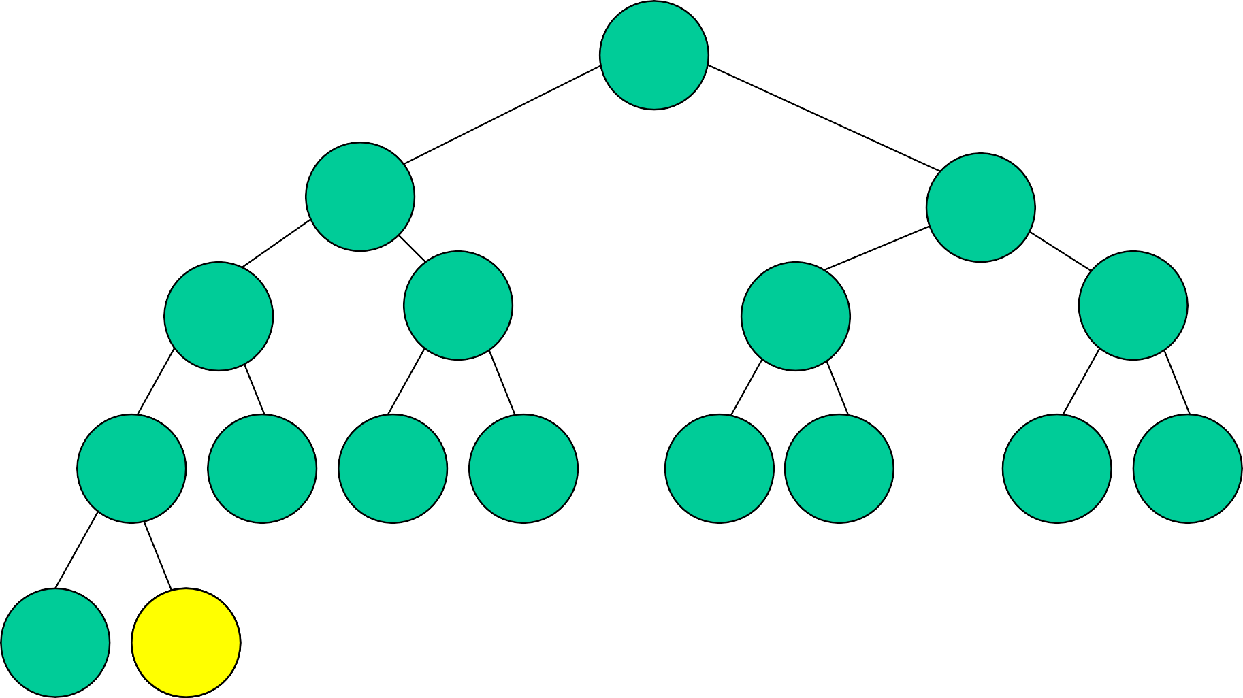10,90

15,80 30,60

20,70

15,20

45,60

35,50

25,60 30,50 16,19 17,17 50,55 47,58 40,45 40,43

28,55

2375,35

Insert 27.

New element becomes a left end point.

Insert new element into min heap.

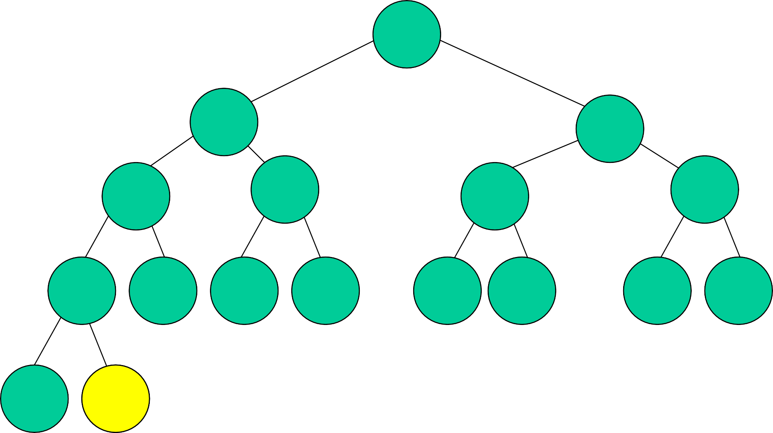10,90

15,80 30,60

20,70

15,20

45,60

35,50

25,60 30,50 16,19 17,17 50,55 47,58 40,45 40,43

28,55 35

Insert 18.

New element becomes a left end point.

Insert new element into min heap.

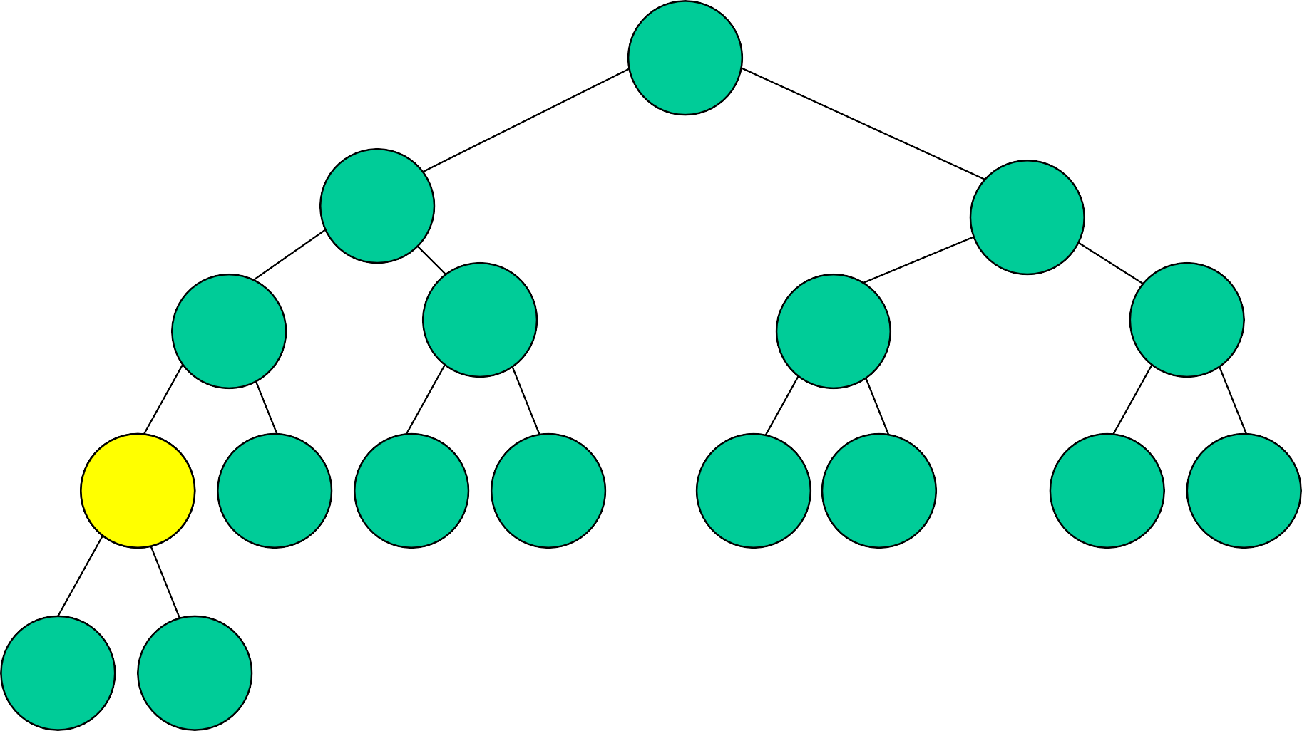10,90

15,80 30,60

20,70

15,20

45,60

35,50

2,56,060 30,50 16,19 17,17 50,55 47,58 40,45 40,43

28,55 25,35

Insert 18.

New element becomes a left end point.

Insert new element into min heap.

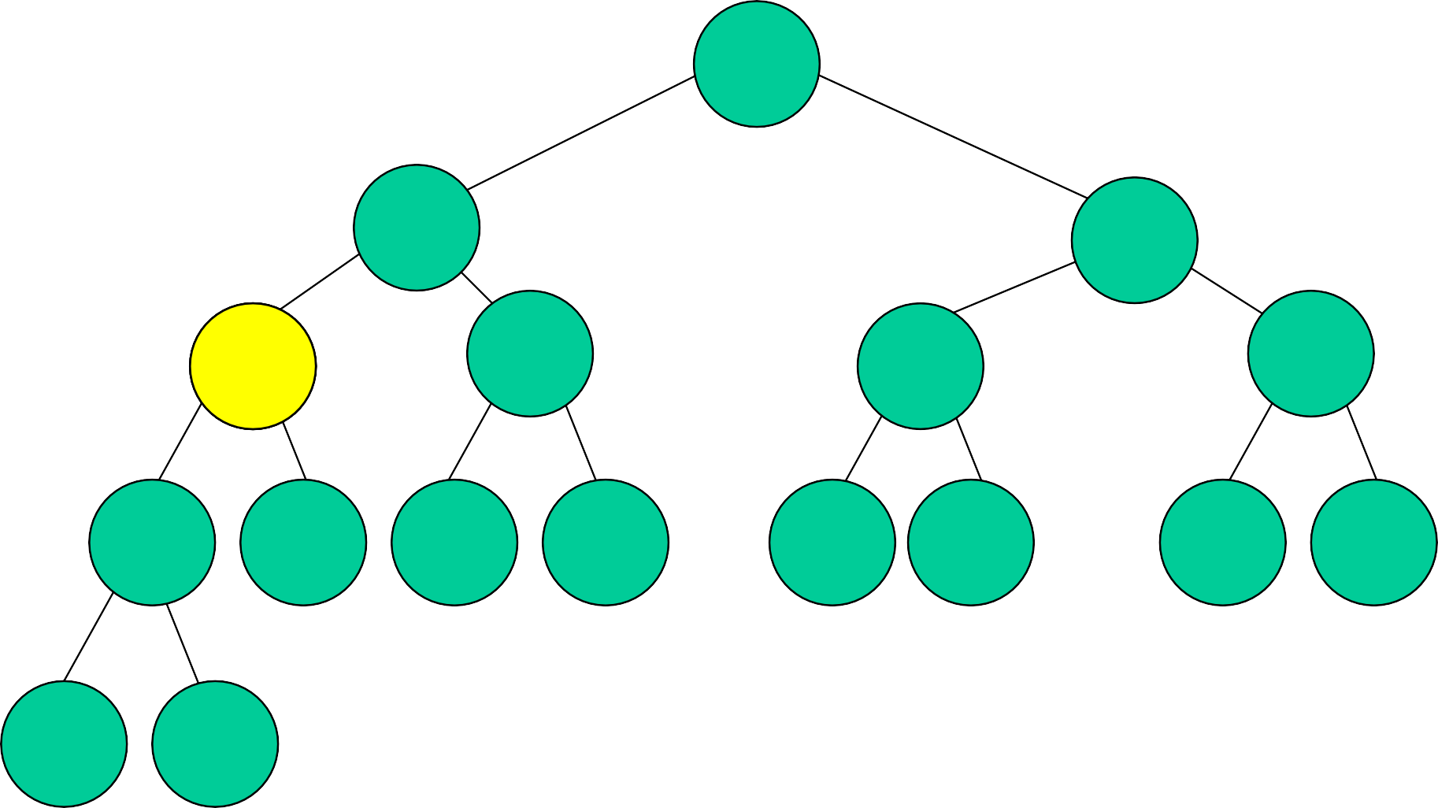10,90

15,80 30,60

21,087,070

15,20

45,60

35,50

20,60 30,50 16,19 17,17 50,55 47,58 40,45 40,43

28,55 25,35

Insert 18.

New element becomes a left end point.

Insert new element into min heap.

# Yet Another Insert

10,90

15,80 30,60

20,70

15,20

45,60

35,50

25,60 30,50 16,19 17,17 50,55 47,58 40,45 40,43

28,55 35

Insert 82.

New element becomes a right end point.

Insert new element into max heap.

# After 82 Inserted

10,90

15,82 30,60

20,80

15,20

45,60

35,50

25,70 30,50 16,19 17,17 50,55 47,58 40,45 40,43

28,55 35,60

# One More Insert Example

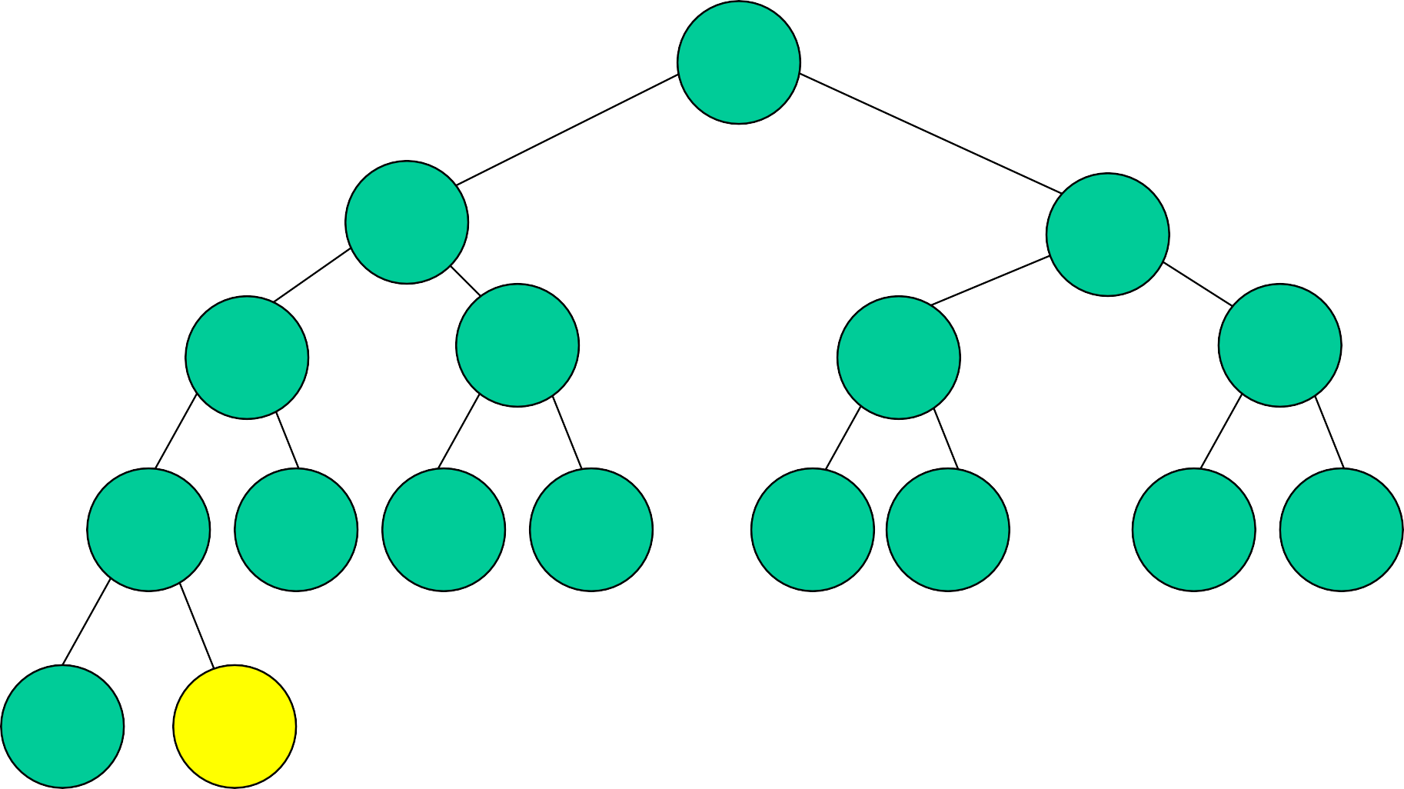10,90

15,82 30,60

20,80

15,20

45,60

35,50

25,70 30,50 16,19 17,17 50,55 47,58 40,45 40,43

28,55

Insert 8.

New element becomes both a left and a right end point.

Insert new element into min heap.

# After 8 Is Inserted

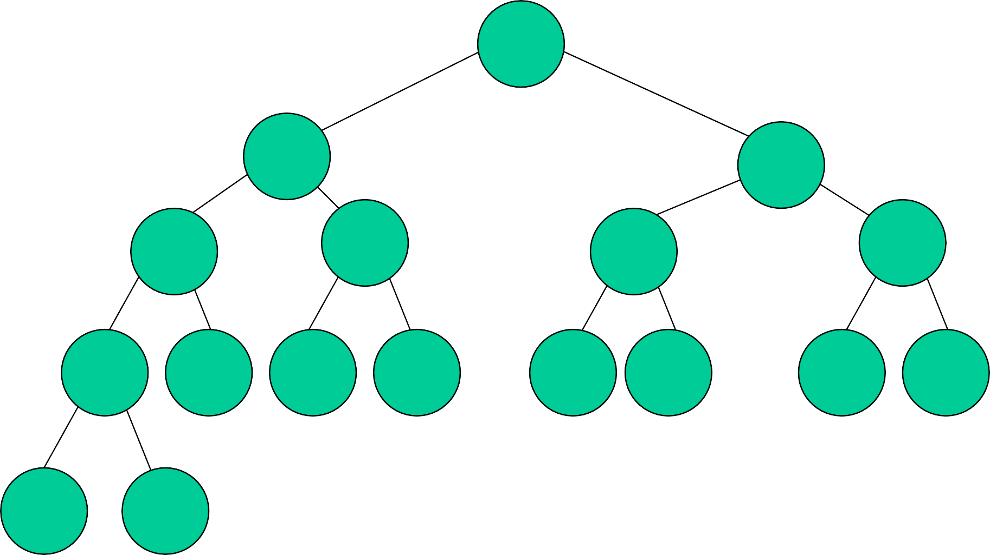8,90

10,82 30,60

15,80

15,20

45,60

35,50

20,70 30,50 16,19 17,17 50,55 47,58 40,45 40,43

28,55 25

# Remove Min Element

* n = 0 => fail.
* n = 1 => heap becomes empty.
* n = 2 => only one node, take out left end point.
* n > 2 => not as simple.

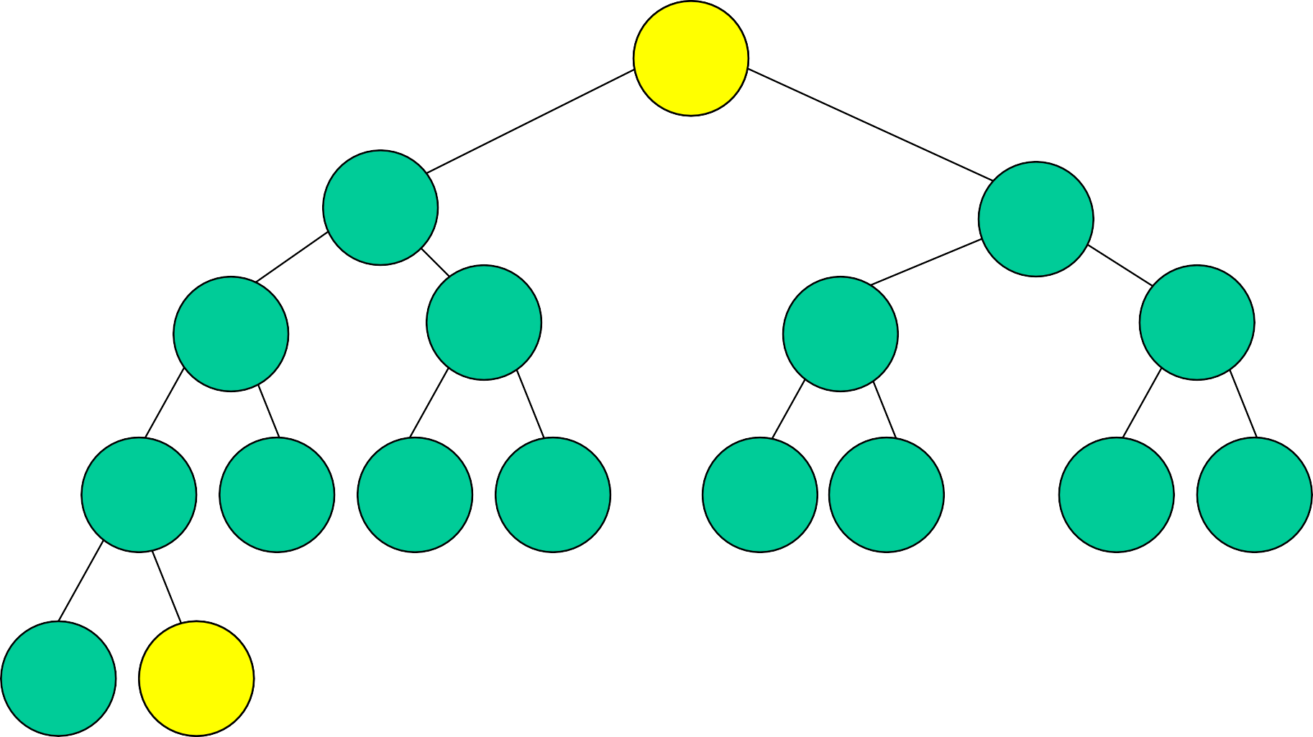1,09,090 35

15,82 30,60

20,80

15,20

45,60

35,50

25,70 30,50 16,19 17,17 50,55 47,58 40,45 40,43

28,55 3,56,060

Remove left end point from root. Remove left end point from last node. Delete last node if now empty.

Reinsert into min heap, begin at root.

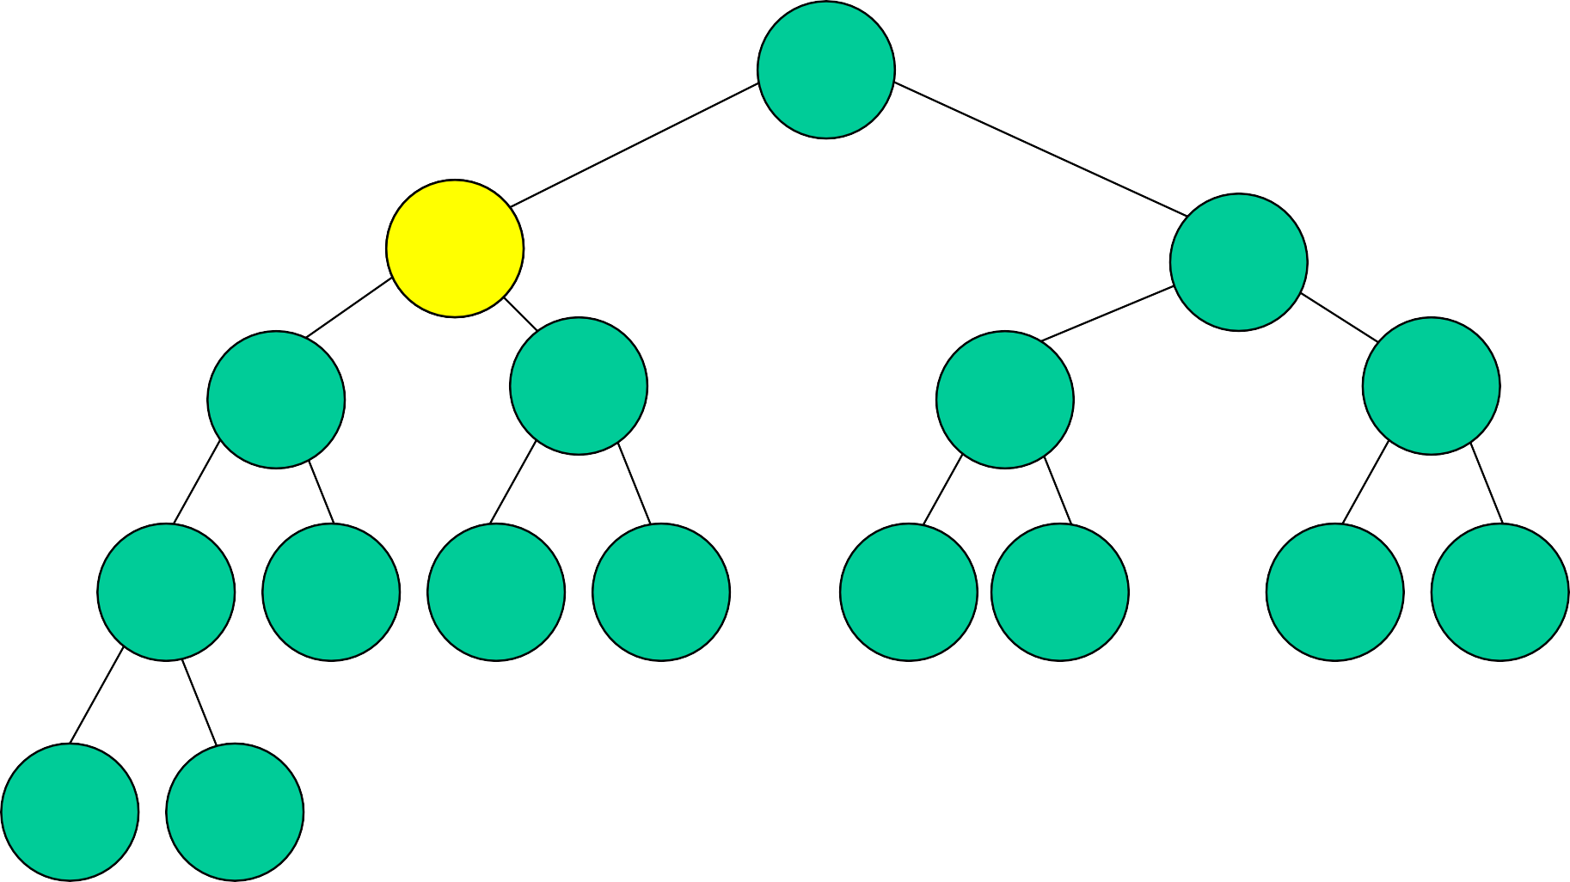15,90

35

1,58,282 30,60

20,80

15,20

45,60

35,50

25,70 30,50 16,19 17,17 50,55 47,58 40,45 40,43

28,55 60

Swap with right end point if necessary.

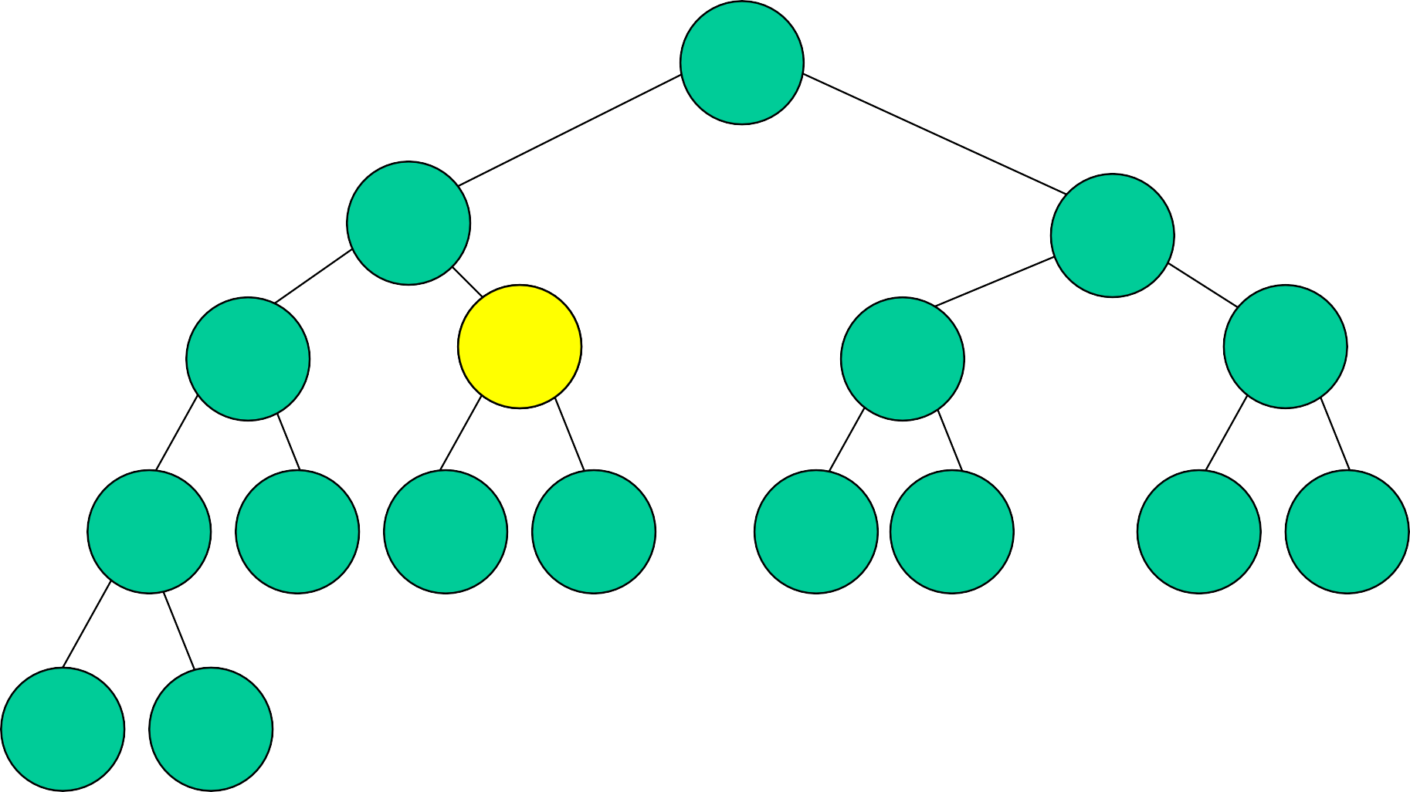15,90

15,82 30,60

35

20,80

1,52,020

45,60

35,50

25,70 30,50 16,19 17,17 50,55 47,58 40,45 40,43

28,55 60

Swap with right end point if necessary.

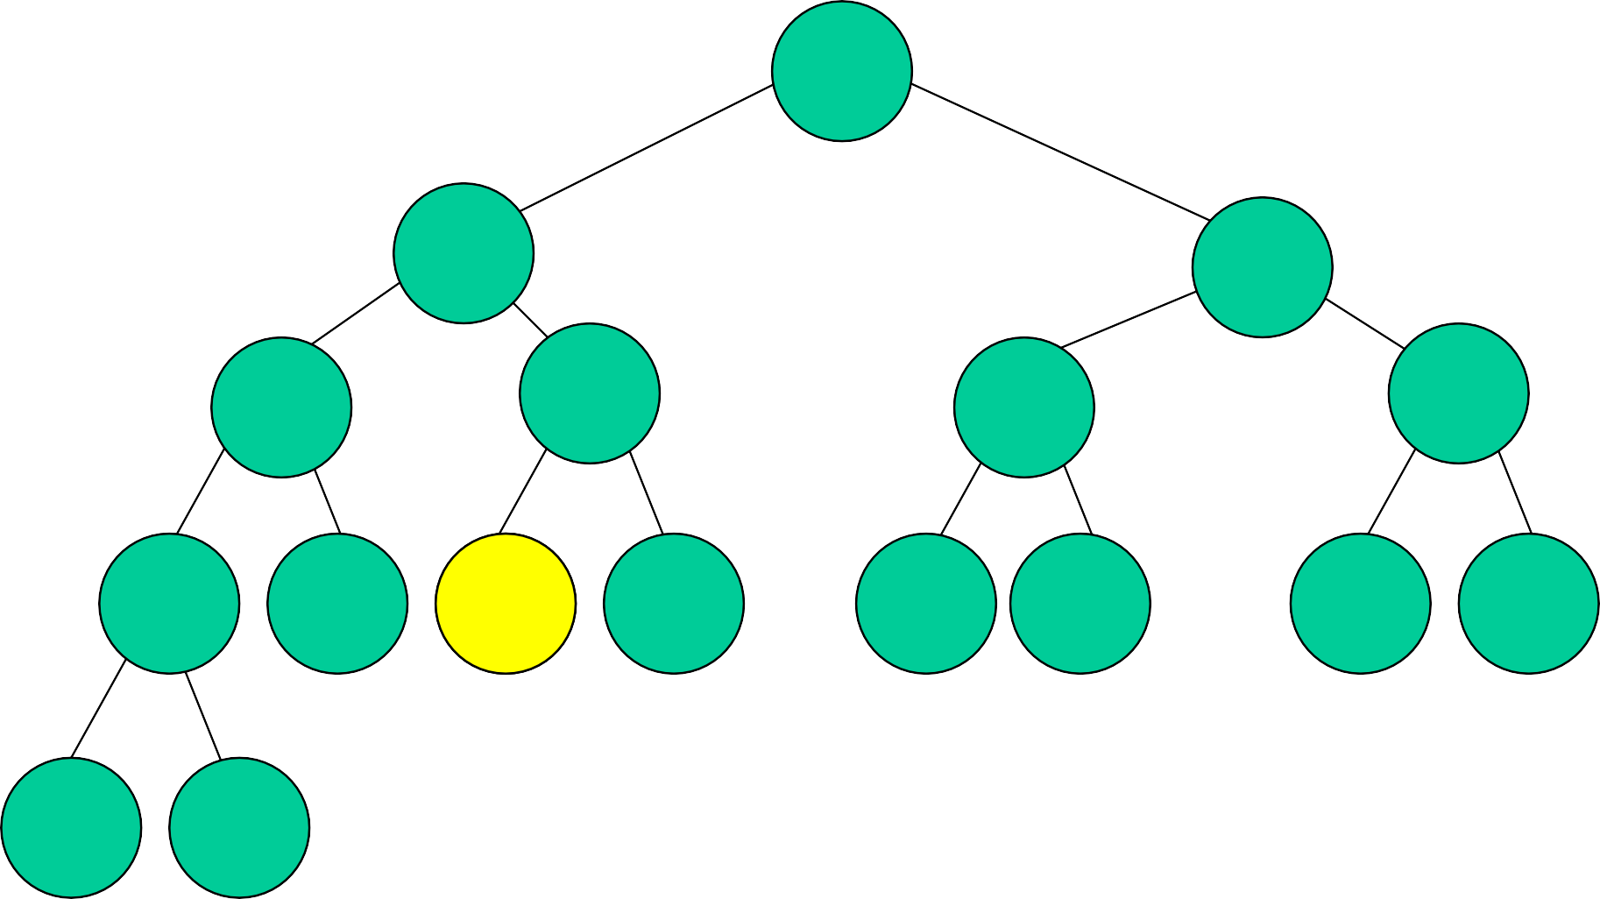15,90

15,82 30,60

20,80

16,35

20

45,60

35,50

25,70 30,50 1,61,919 17,17 50,55 47,58 40,45 40,43

28,55 60

Swap with right end point if necessary.

15,90

15,82 30,60

20,80

16,35

45,60

35,50

25,70 30,50 19,20 17,17 50,55 47,58 40,45 40,43

28,55 60

# Initialize

70,39

99,82 1,12

20,23

48,20

49,63

35,50

25,19 57,50 46,19 17,37 50,25 47,28 20,45 40,13

68,55 35,14

Examine nodes bottom to top.

Swap end points in current root if needed. Reinsert left end point into min heap.

Reinsert right end point into max heap.

# Cache Optimization

* Heap operations.
  + Uniformly distributed keys.
  + Insert bubbles approx. 1.6 levels up the heap on average.
  + Remove min (max) height – 1 levels down the heap.
* Optimize cache utilization for remove min (max).

# Cache Aligned Array

* Cache line is 32 bytes.
* Heap node size is 8 bytes (1 8-byte element).
* 4 nodes/cache line.

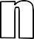

|  |  |  |  |  |  |  |  |  |  |  |  |  |  |  |  |  |  |  |  |  |  |  |  |
| --- | --- | --- | --- | --- | --- | --- | --- | --- | --- | --- | --- | --- | --- | --- | --- | --- | --- | --- | --- | --- | --- | --- | --- |
|  | 1 | 2 | 3 | 4 | 5 | 6 | 7 |  |  |  |  |  |  |  |  |  |  |  |  |  |  |  |  |

* A remove min (max) has ~h cache misses on average.

0

1

2

3

4

5

6

7

* + Root and its children are in the same cache line.
  + ~log2n cache misses.
  + Only half of each cache line is used (except root’s).

# d-ary Heap

* Complete n node tree whose degree is d.
* Min (max) tree.
* Number nodes in breadth-first manner with root being numbered 1.
* Parent(i) = ceil((i – 1)/d).
* Children are d*(i – 1) + 2, …, min{d*i + 1, n}.
* Height is logdn.
* Height of 4-ary heap is half that of 2-ary heap.

# d = 4, 4-Heap

* Worst-case insert moves up half as many levels as when d = 2.
  + Average remains at about 1.6 levels.
* Remove-min operations now do 4 compares per level rather than 2 (determine smallest child and see if this child is smaller than element being relocated).
  + But, number of levels is half.
  + Other operations associated with remove min are halved (move small element up, loop iterations, etc.)

# 4-Heap Cache Utilization

* Standard mapping into cache-aligned array.

0

1

2

3

4

5

6

7

|  |  |  |  |  |  |  |  |  |  |  |  |  |  |  |  |  |  |  |  |  |  |  |  |
| --- | --- | --- | --- | --- | --- | --- | --- | --- | --- | --- | --- | --- | --- | --- | --- | --- | --- | --- | --- | --- | --- | --- | --- |
|  | 1 | 2 | 3 | 4 | 5 | 6 | 7 |  |  |  |  |  |  |  |  |  |  |  |  |  |  |  |  |

* Siblings are in 2 cache lines.
  + ~log2n cache misses for average remove min (max).
* Shift 4-heap by 2 slots.

0

1

2

3

4

5

6

7

|  |  |  |  |  |  |  |  |  |  |  |  |  |  |  |  |  |  |  |  |  |  |  |  |
| --- | --- | --- | --- | --- | --- | --- | --- | --- | --- | --- | --- | --- | --- | --- | --- | --- | --- | --- | --- | --- | --- | --- | --- |
| - | - | - | 1 | 2 | 3 | 4 | 5 |  |  |  |  |  |  |  |  |  |  |  |  |  |  |  |  |

* Siblings are in same cache line.
  + ~log4n cache misses for average remove min (max).

# d-ary Heap Performance

* Speedup of about 1.5 to 1.8 when sorting a large number of elements using heapsort and cache-aligned 4-heap vs. 2-heap that begins at array position 0.
* Cache-aligned 4-heap generally performs as well as, or better, than other d-heaps.
* Use degree 4 complete tree for interval heaps instead of degree 2.

# Application Of Interval Heaps

* Complementary range search problem.
  + Collection of 1D points (numbers).
  + Insert a point.
    - O(log n)
  + Remove a point given its location in the structure.
    - O(log n)
  + Report all points not in the range [a,b], a <= b.
    - O(k), where k is the number of points not in the range.

10,90

15,80 30,60

20,70

15,20

45,60

35,50

25,60 30,50 16,19 17,17 50,55 47,58 40,45 40,43

28,55 35

[5,100]

[2,65]

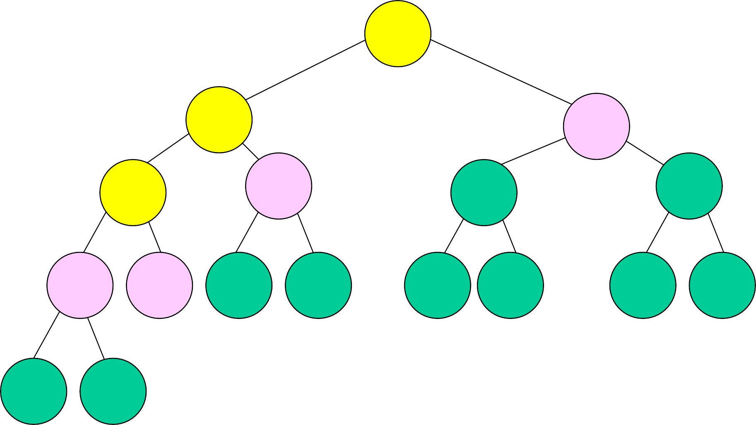10,90

15,80 30,60

20,70

15,20

45,60

35,50

25,60 30,50 16,19 17,17 50,55 47,58 40,45 40,43

28,55 35

[2,65]

# Leftist Trees

Linked binary tree.

Can do everything a heap can do and in the same asymptotic complexity.

* insert
* remove min (or max)
* arbitrary remove (need parent pointers)
* initialize

Can meld two leftist tree priority queues in O(log n) time.

# Extended Binary Trees

Start with any binary tree and add an external node wherever there is an empty subtree.

Result is an extended binary tree.

# A Binary Tree

An Extended Binary Tree

number of external nodes is n+1

# The Function s()

For any node x in an extended binary tree, let s(x) be the length of a shortest path from x to an external node in the subtree rooted at x.

2

0

0

0

0

0

0

2 1

2 1 1

1 1 1

0 0 0 0

# Properties Of s()

If x is an external node, then s(x) = 0. Otherwise,

s(x) = min {s(leftChild(x)),

s(rightChild(x))} + 1

# (Height Biased) Leftist Trees

A binary tree is a (height biased) leftist tree iff for every internal node x, s(leftChild(x)) >= s(rightChild(x))

So, in a leftist tree, s(x) = s(rightChild) + 1.

# A Leftist Tree

0

0

0

0

0

0

2

2 1

2 1 1

1 1 1

0 0 0 0

s() decreases by 1 each time you move to a right child how about when you move to a left child?

subtrees are also leftist trees

# Leftist Trees – Property 1

In a leftist tree, the rightmost path is a shortest root to external node path and the length of this path is s(root).

# A Leftist Tree

2

0

0

0

0

0

0

2 1

2 1 1

1 1 1

0 0 0 0

Length of rightmost path is 2.

# Leftist Trees—Property 2

The number of internal nodes is at least

2s(root) - 1

Because levels 1 through s(root) have no external nodes.

# A Leftist Tree

2

0

0

0

0

0

0

2 1

2 1 1

1 1 1

0 0 0 0

Levels 1 and 2 have no external nodes. Max # of internal nodes?

# Leftist Trees—Property 3

Length of rightmost path is O(log n), where n is the number of (internal) nodes in a leftist tree.

Property 2 =>

* n >= 2s(root) – 1 => s(root) <= log2(n+1)

Property 1 => length of rightmost path is s(root).

# Leftist Trees As Priority Queues

Min leftist tree … leftist tree that is a min tree.

Used as a min priority queue.

Max leftist tree … leftist tree that is a max tree.

Used as a max priority queue.

# A Min Leftist Tree

2

4

3

6

8

5

8

6

9

Some Min Leftist Tree Operations

findMin() put() removeMin() meld() initialize()

put() and removeMin() use meld().

put(7)

# Put Operation

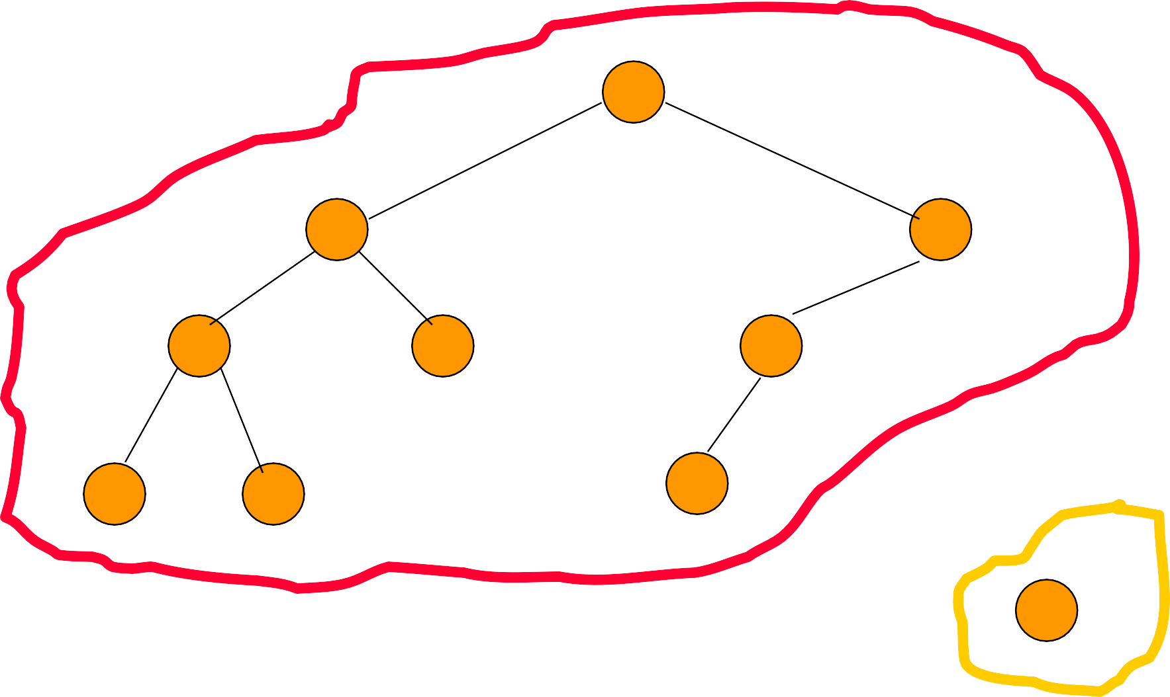2

4 3

6 8 5

8 6 9

Create a single node min leftist tree. 7

Meld the two min leftist trees.

2

4

3

6

8

5

8

6

9

Remove the root.

3

5

9

2

4

6

8

8

6

Remove the root. Meld the two subtrees.

4

6

8

8

6

3

5

6

9

Traverse only the rightmost paths so as to get logarithmic performance.

4

6

8

8

6

3

5

6

9

Meld right subtree of tree with smaller root and all of other tree.

Make the result the new right subtree of the smaller root.

Swap left and right subtrees if needed.

4

6

8

8

6

3

5

9

6

Meld right subtree of tree with smaller root and all of other tree.

6

8

8

6

Meld right subtree of tree with smaller root and all of other tree.

Meld right subtree of tree with smaller root and all of other tree.

Right subtree of 6 is empty. So, result of melding right subtree of tree with smaller root and other tree is the other tree.

6

8

8

6

Make melded subtree right subtree of smaller root.

6

8

Swap left and right subtrees if s(left) < s(right).

4

6

8

6

6

8

4

6

6

8

6

8

Make melded subtree right subtree of smaller root.

Swap left and right subtree if s(left) < s(right).

3

5

4

9

6

6

8

6

8

Make melded subtree right subtree of smaller root.

Swap left and right subtree if s(left) < s(right).

3

4

5

6

6

9

8

6

8

# Initializing In O(n) Time

* Create n single-node min leftist trees and place them in a FIFO queue.
* Repeatedly remove two min leftist trees from the FIFO queue, meld them, and put the resulting min leftist tree into the FIFO queue.
* The process terminates when only 1 min leftist tree remains in the FIFO queue.
* Analysis is the same as for heap initialization.

# Arbitrary Remove

Remove element in node pointed at by x.

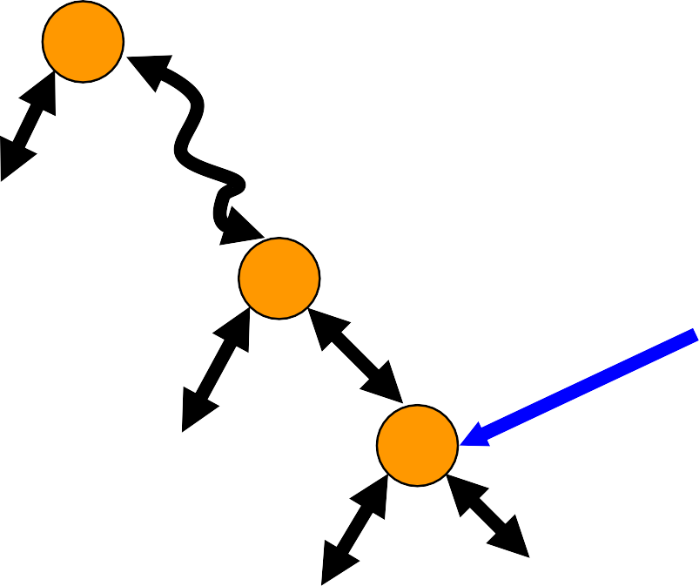A

x

B

L R

x = root => remove min.

# Arbitrary Remove, x != root

1. 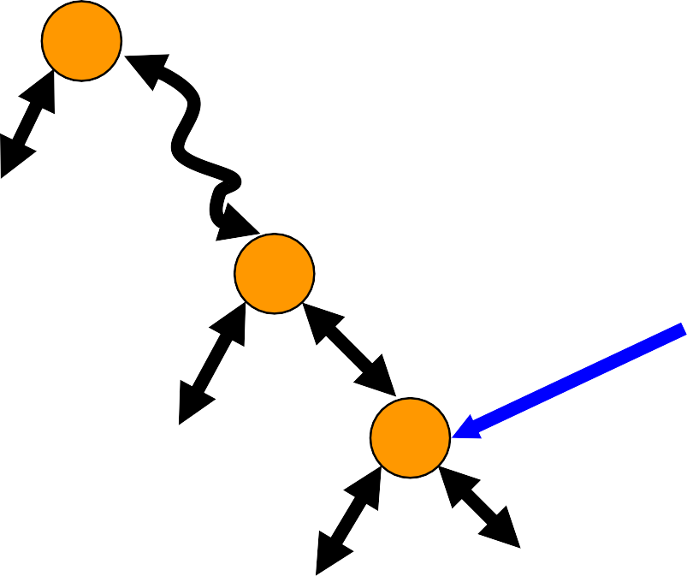p

x

B

L R

Make L right subtree of p.

Adjust s and leftist property on path from p to root (stop at first node, if any, whose s value does not change).

Meld with R.

# Skew Heap

* + Similar to leftist tree
  + No s() values stored
  + Swap left and right subtrees of all nodes on rightmost path rather than just when s(l(x)) < s(r(x))
  + Amortized complexity of insert, remove min, and meld is O(log n)

# Binomial Heaps

|  |  |  |  |
| --- | --- | --- | --- |
|  | Leftist trees | Binomial heaps | |
| Actual | Amortized |
| Find min (or max) | O(1) | O(1) | O(1) |
| Insert | O(log n) | O(1) | O(1) |
| Remove min (or max) | O(log n) | O(n) | O(log n) |
| Meld | O(log n) | O(1) | O(1) |

Min Binomial Heap

6

5

9

5

9

* + Collection of min trees.

4

1

7

3

8

2

4

5

9

6

7

6

8

# Node Structure

* Degree
  + Number of children.
* Child
  + Pointer to one of the node’s children.
  + Null iff node has no child.
* Sibling
  + Used for circular linked list of siblings.
* Data

# Binomial Heap Representation

* Circular linked list of min trees. A

2 1

4

4 5 9 7 3

6 7 6

8

8

5

5

6 9 Degree fields

9 not shown.

# Insert 10

* Add a new single-node min tree to the collection.
* Update min-element pointer if necessary.

A

1

4

2

4

5

9

6

7

6

8

7 3

5

9

10

8

5

9

6

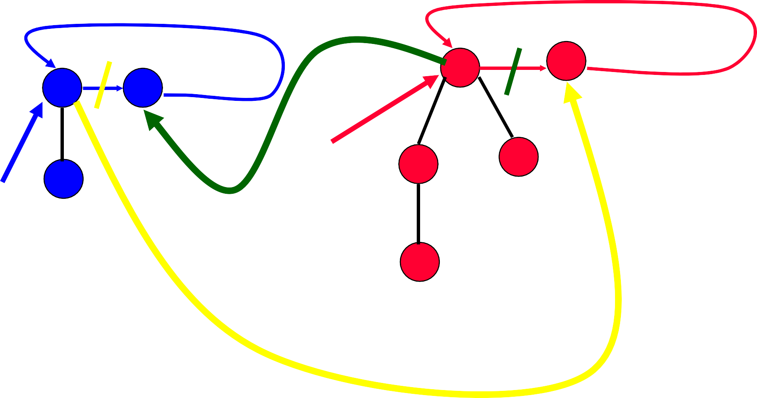1 4

5 7

B 7 3

9

A

8

* Combine the 2 top-level circular lists.
* Set min-element pointer.

1

4

7

3

8

5

7

9

C

# Remove Min

* + Empty binomial heap => fail.

# Nonempty Binomial Heap

10

6

5

9

5

9

* Remove a min tree.
* Reinsert subtrees of removed min tree.

A

1

7

3

8

* Update binomial heap pointer.

4

2

4

5

9

6

7

6

8

# Remove Min Tree

* Same as remove an element from a circular list.

c

a

b

d

d

e

A

* + No next node => empty after remove.
  + Otherwise, copy next-node data and remove next node.

# Reinsert Subtrees

5

7

A

9

1

4

7

3

B

8

subtrees

* Combine the 2 top-level circular lists.
  + Same as in meld operation.

# Update Binomial Heap Pointer

* Must examine roots of all min trees to determine the min value.

# Complexity Of Remove Min

* Remove a min tree.
* O(1).
* Reinsert subtrees.
* O(1).
* Update binomial heap pointer.
* O(s), where s is the number of min trees in final top-level

circular list.

* s = O(n).
* Overall complexity of remove min is O(n).

# Correct Remove Min

* + During reinsert of subtrees, pairwise combine min trees whose roots have equal degree.
  + This is essential to get stated amortized bounds and so is the correct way to remove from a Binomial heap.
  + The simple remove min described earlier does not result in the desired amortized complexity and so is incorrect for Binomial heaps.

10

4

1

7

3

8

Examine the s = 7 trees in some order. Determined by the 2 top-level circular lists.

6

5

9

5

9

2

4

5

9

6

7

6

8

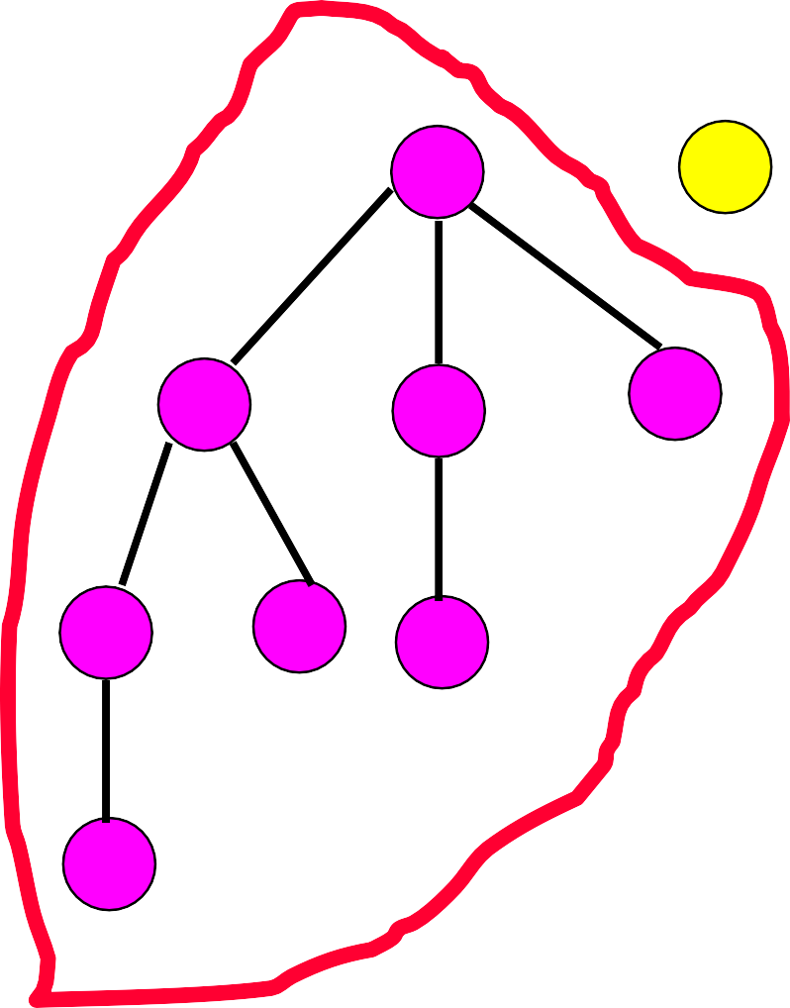

2

4

4

5

9

6

7

6

8

10

5

9

6

1

7

3

8

5

9

4

3

tree table 2

1

0

Use a table to keep track of trees by degree.

10

5

9

6

1

7

3

8

5

9

4

2

4

4

5

9

6

7

6

8

3

tree table 2

1

0

4

10

5

9

6

1

7

3

8

5

9

Combine 2 min trees of degree 0.

2

4

5

9

6

7

6

8

4

3

tree table 2

1

0

Make the one with larger root a subtree of other.

4

10

5

9

6

1

7

3

8

5

9

Update tree table.

2

4

5

9

6

7

6

8

4

3

tree table 2

1

0

4

10

5

6

9

1

7

3

8

5

9

Combine 2 min trees of degree 1.

2

4

5

9

6

7

6

8

4

3

tree table 2

1

0

Make the one with larger root a subtree of other.

4

10

5

9

6

1

7

3

8

5

9

Update tree table.

2

4

5

9

6

7

6

8

4

3

tree table 2

1

0

4

10

5

9

6

1

7

3

8

5

9

4

3

2

4

5

9

6

7

6

8

tree table 2

1

0

4

10

5

9

Combine 2 min trees of degree 2.

2

4

5

9

6

7

6

8

4

3

1

7

3

8

tree table 2

1

0

Make the one with larger root a subtree of other.

6

5

9

1

6

5

9

2

4

5

9

6

7

6

8

4 7 3

10 5 8

Combine 2 min trees of degree 3.

9 4

3

tree table 2

1

0

Make the one with larger root a subtree of other.

1

6

5

9

2 4 7 3

4 5 9 10 5 8

6 7 6

8

9

4

|  |
| --- |
|  |
|  |
|  |
|  |
|  |

3

tree table 2

1

0

Update tree table.

1

6

5

9

2 4 7 3

4 5 9 10 5 8

6 7 6

8

9

4

3

tree table 2

1

0

1

6

5

9

2 4 7 3

4 5 9 10 5 8

6 7 6

8

9

4

3

tree table 2

1

0

Create circular list of remaining trees.

# Complexity Of Correct Remove Min

* Remove tree with min element. O(1)
* Reinsert its subtrees. O(1)
* Create and initialize tree table.
  + O(MaxDegree).
  + Done once only.
* Examine s min trees and pairwise combine.
  + O(s).
* Collect remaining trees from tree table, reset table entries to null, and set binomial heap pointer.
  + O(MaxDegree).
* Overall complexity of remove min.
  + O(MaxDegree + s).

# Binomial Trees

* Bk is degree k binomial tree.

B0 

* + Bk , k > 0, is:

…

1. B1 B2 Bk-1

0

# Examples

**B0** **B1** **B2** **B3**

# Number Of Nodes In Bk

* Nk = number of nodes in Bk.

B0

* + Bk , k > 0, is:

N0 = 1

…

B B1 B2 Bk-1

0

* + - Nk = N0 + N1 + N2 + …+ Nk-1 + 1

= 2k.

# Equivalent Definition

**B1** **B2** **B3**

* Bk , k > 0, is two Bk-1s.
* One of these is a subtree of the other.

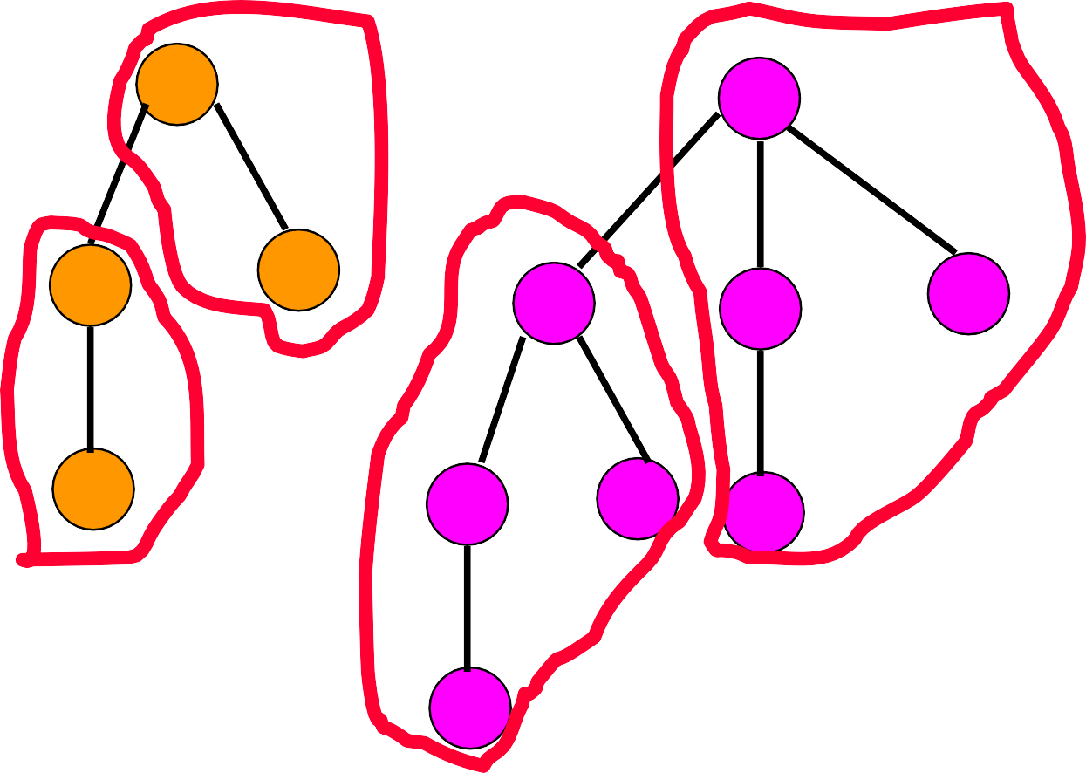

# Nk And MaxDegree

* + N0 = 1
  + Nk = 2Nk-1

= 2k.

* + If we start with zero elements and perform operations as described, then all trees in all binomial heaps are binomial trees.
  + So, MaxDegree = O(log n).

# Analysis Of Binomial Heaps

|  |  |  |  |
| --- | --- | --- | --- |
|  | Leftist trees | Binomial heaps | |
| Actual | Amortized |
| Find min (or max) | O(1) | O(1) | O(1) |
| Insert | O(log n) | O(1) | O(1) |
| Remove min (or max) | O(log n) | O(n) | O(log n) |
| Meld | O(log n) | O(1) | O(1) |

Operations

* Insert
  + Add a new min tree to top-level circular list.
* Meld
  + Combine two circular lists.
* Remove min
  + Pairwise combine min trees whose roots have equal degree.
  + O(MaxDegree + s), where s is number of min trees following removal of min element but before pairwise combining.
  + Bk is degree k binomial tree.

B0 

* + - Bk , k > 0, is:

…

B B1 B2 Bk-1

0

* Bk , k > 0, is two Bk-1s.
* 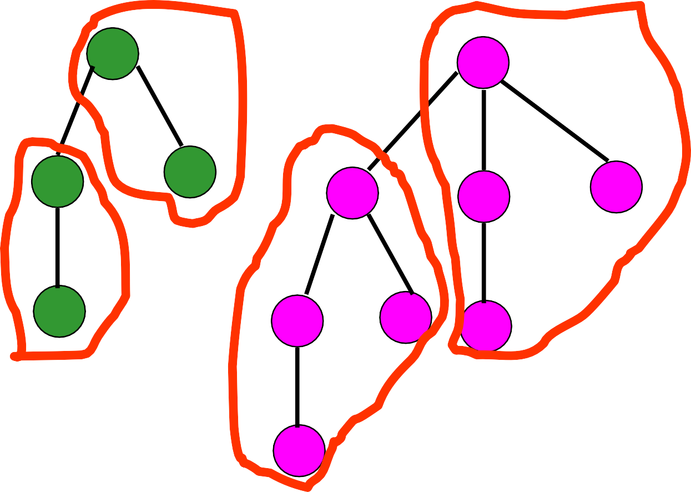One of these is a subtree of the other.

**B0** **B1** **B2** **B3**

# All Trees In Binomial Heap Are Binomial Trees

* + Initially, all trees in system are Binomial trees (actually, there are no trees initially).
  + Assume true before an operation, show true after the operation.
  + Insert creates a B0.
  + Meld does not create new trees.
  + Remove Min
* Reinserted subtrees are binomial trees.
* Pairwise combine takes two trees of equal degree and makes one a subtree of the other.

# Complexity of Remove Min

* + Let n be the number of inserts.
* No binomial tree has more than n elements.
* MaxDegree <= log2n.
* Complexity of remove min is O(log n + s) = O(n).

# Aggregate Method

* + - Get a good bound on the cost of every sequence of operations and divide by the number of operations.
    - Results in same amortized cost for each operation, regardless of operation type.
    - Can’t use this method, because we want to establish a different amortized cost for remove mins than for inserts and melds.

# Aggregate Method – Alternative

* + Get a good bound on the cost of every sequence of remove mins and divide by the number of remove mins.
  + Consider the sequence insert, insert, …, insert,

remove min.

* The cost of the remove min is O(n), where n is the number of inserts in the sequence.
* So, amortized cost of a remove min is O(n/1) = O(n).

# Accounting Method

* + - Guess the amortized cost.
      * Insert => 2.
      * Meld => 1.
      * Remove min => 3log2n.
    - Show that P(i) – P(0) >= 0 for all i.

# Potential Function

* P(i) = amortizedCost(i) – actualCost(i) + P(i – 1)
* P(i) – P(0) is the amount by which the first i operations have been over charged.
* We shall use a credit scheme to keep track of (some of) the over charge.
* There will be 1 credit on each min tree.
* Initially, #trees = 0 and so total credits and P(0) = 0.
* Since number of trees cannot be <0, the total credits is always >= 0 and hence P(i) >= 0 for all i.

# Insert



* + Guessed amortized cost = 2.
  + Use 1 unit to pay for the actual cost of the insert.
  + Keep the remaining 1 unit as a credit.
  + Keep this credit with the min tree that is created by the insert operation.
  + Potential increases by 1, because there is an overcharge of 1.

# Meld



* + Guessed amortized cost = 1.
  + Use 1 unit to pay for the actual cost of the meld.
  + Potential is unchanged, because actual and amortized costs are the same.
* Let MinTrees be the set of min trees in the binomial heap just before remove min.
* Let u be the degree of min tree whose root is removed.
* Let s be the number of min trees in binomial heap just before pairwise combining.
* s = #MinTrees + u – 1
* Actual cost of remove min is <= MaxDegree + s

<= 2log2n –1+ #MinTrees.

* + Guessed amortized cost = 3log2n.
  + Actual cost <= 2log2n – 1 + #MinTrees.
  + Allocation of amortized cost.
    - Use up to 2log2n – 1 to pay part of actual cost.
    - Keep some or all of the remaining amortized cost as a credit.
    - Put 1 unit of credit on each of the at most log2n + 1 min trees left behind by the remove min operation.
    - Discard the remainder (if any).

Paying Actual Cost Of A Remove Min

* + Actual cost <= 2log2n – 1 + #MinTrees
  + How is it paid for?
    - 2log2n –1 comes from amortized cost of this remove min operation.
    - #MinTrees comes from the min trees themselves, at the rate of 1 unit per min tree, using up their credits.
    - Potential may increase or decrease but remains nonnegative as each remaining tree has a credit.

# Potential Method

* Guess a suitable potential function for which P(i) – P(0) >= 0 for all i.
* Derive amortized cost of ith operation using

P = P(i) – P(i – 1)

= amortized cost – actual cost

* amortized cost = actual cost + P

# Potential Function

* P(i) = #MinTrees(j)
  + #MinTrees(j) is #MinTrees for binomial heap j.
  + When binomial heaps A and B are melded, A and B are no longer included in the sum.
* P(0) = 0
* P(i) >= 0 for all i.
* ith operation is an insert.
  + Actual cost of insert = 1
  + P = P(i) – P(i – 1) = 1
  + Amortized cost of insert = actual cost + P

= 2

# ith Operation Is A Meld

* Actual cost of meld = 1
* P(i) = #MinTrees(j)
* P = P(i) – P(i – 1) = 0
* Amortized cost of meld = actual cost + P

= 1

# ith Operation Is A Remove Min

* old => value just before the remove min
* new => value just after the remove min.
* #MinTreesold(j) => value of #MinTrees in jth binomial heap just before this remove min.
* Assume remove min is done in kth binomial heap.

# ith Operation Is A Remove Min

* Actual cost of remove min from binomial heap k

<= 2log2n – 1 + #MinTreesold(k)

* P = P(i) – P(i – 1)

= [#MinTreesnew(j) – #MinTreesold(j)]

= #MinTreesnew(k) – #MinTreesold(k).

* Amortized cost of remove min = actual cost + P

<= 2log2n – 1 + #MinTreesnew (k)

<= 3log2n.

# Actual Cost Of Any Operation Sequence

* + Start with empty Binomial heaps
  + Do i inserts, m melds, and r remove mins
  + Actual cost is O(i + m + r log i)